
i

THE INDEPENDENT STATE OF PAPUA NEW GUINEA

PAPUA NEW GUINEA VISION 2050

National Strategic Plan Taskforce

“WE LEADERS AND PEOPLE MUST KNOW WHERE WE WANT TO GO BEFORE WE CAN DECIDE HOW WE SHOULD GET THERE. BEFORE A DRIVER STARTS A MOTOR CAR, HE SHOULD FIRST DECIDE ON HIS DESTINATION. OTHERWISE HIS DRIVING WILL BE WITHOUT PURPOSE, AND HE WILL ACHIEVE NOTHING. WE PAPUA NEW GUINEANS ARE NOW IN THE DRIVING SEAT. THE ROAD WHICH WE SHOULD FOLLOW OUGHT TO BE MARKED OUT SO THAT ALL WILL KNOW THE WAY AHEAD.”

(Constitutional Planning Committee (CPC) Report, 1974, Chapter 2, Section 4)
ii
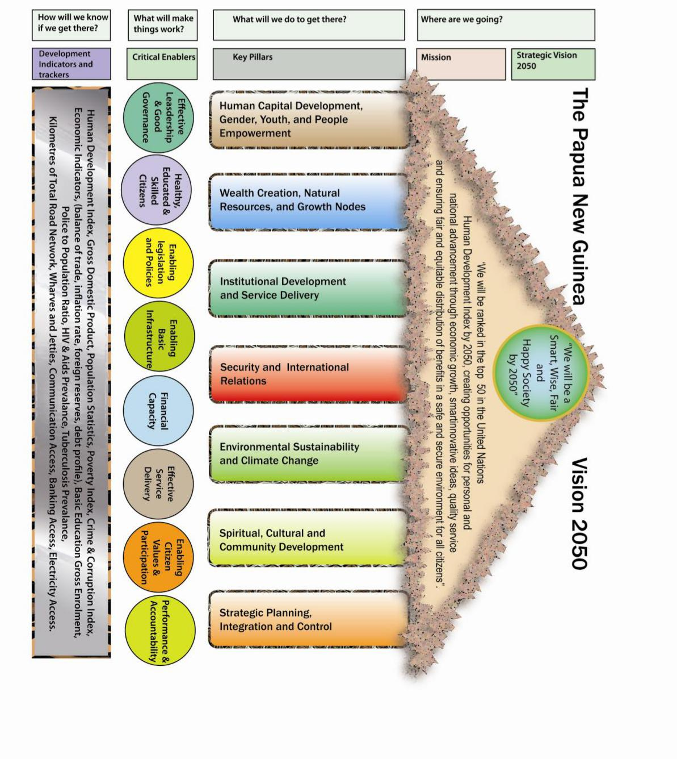

ii

CONTENTS

ABBREVIATIONS v

THE NEXT GENERATION OF NATION BUILDERS x

VISION 2050: OUR PEOPLE’S VISION xii

EXECUTIVE SUMMARY xiv

DIRECTIONAL AND ENABLING STATEMENTS 1

Directional Statement 1

Pillars for the Vision 3

1.17 Human Development, Gender, Youth and People Empowerment 5

1.18 Public Investment Budget Strategy 11

Enabling Statement: Ensuring a Systemic Change 12

1.19 Leadership 12

1.20 Human Resources 12

1.21 Legislation 12

1.22 Finance 13

1.23 Infrastructure 13

1.24 Service Delivery Mechanism 13

1.25 Citizen Participation 14

1.26 Monitoring and Accountability 14

CHAPTER ONE: WHY A 40-YEAR VISION 2050? 15

Brief Facts about Papua New Guinea 15

A Brief History of Development Planning 15

Socioeconomic Development Experience 16

22. Summary 19

CHAPTER TWO: CURRENT SCENE AND FUTURE SCENARIOS 20

3. Summary 29

CHAPTER THREE: VISION 2050 30

4 Our Vision and Mission 30

5. Our Mission Statement 31

22. Summary 54

iii

CHAPTER FOUR: INSTITUTIONAL FRAMEWORK FOR VISION 2050 55

1. Introduction 55

2. National Ownership and Commitment 55

3. Partnership 55

4. Operational Strategy 56

5. Information and Communication Strategy 56

6. Monitoring Evaluation and Review 56

7. Summary 57

CHAPTER FIVE: THE FUTURE 58

Introduction 58

7. Summary 59

References 60

ACKNOWLEDGEMENTS 63
iv

Boxes, Figures, and Tables

Box 1.1 Papua New Guinea in Brie 15

Figure 2.1 Real GDP Growth Scenarios, 2010-2020 27

Table 2.1 Four-Pronged Projected Economic Scenario, 2010-2050 28

Table 2.2 Strategic Target Goals for Vision, 2050 28

Figure 3.1 The Seven Strategic Focus Areas of Vision 2050 27

Table 3.1 Strategies for Strategic Focus Area One: Human Capital Development, Gender, Youth and People

Empowerment. 36

Table 3.2 Strategies for Strategic Focus Area Two: Wealth Creation 37

Table 3.3 Strategies for Strategic Focus Area Three: Institutional Development and Service Delivery 39

Table 3.4 Strategies for Strategic Focus Area Four: Security and International Relations 40

Table 3.5 Strategies for Strategic Focus Area Five: Environmental Sustainability and Climate Change 42

Table 3.6 Strategies for Strategic Focus Area Six: Spiritual, Cultural, and Community Development 43

Table 3.7 Strategies for Strategic Focus Area Seven: Strategic Planning, Integration, and Control 44

Figure 4.1 PNG Vision 2050 Review. 48


v

ABBREVIATIONS

APEC | Asia Pacific Economic Cooperation
ASEAN | Association of South-East Asian Nations
BOP | Balance of Payment
BPNG | Bank of Papua New Guinea
CACC | Central Agencies Coordinating Committee
CPC | Constitutional Planning Committee
CPO | Central Planning Office
DSIP | District Services Improvement Program
DTIP | District Transport Improvement Program
EEF | Education Endowment Fund
EEZ | Exclusive Economic Zone
GDI | Gross Domestic Income
GDP | Gross Domestic Product
GER | Gross Enrolment Rate
GoPNG | Government of Papua New Guinea
HC | Human Capital
HDI | Human Development Index
HIV/AIDS | Human Infected Virus/ Acquired Immune Deficiency Syndrome
HSIP | Health Sector Improvement Program
ICT | Information Communication Technology
IMF | International Monetary Fund
ITDI | Industrial Technology Development Institute
KRA | Key Result Areas
LLG | Local-level Government
LNG | Liquefied Natural Gas
LTDS | Long-Term Development Strategy
MDGs | Millennium Development Goals
MTDS | Medium Term Development Strategy
NACS | National Aids Council Secretariat
NADP | National Agriculture Development Plan
NCAMA | National Curriculum Assessment and Monitoring Authority
NDOH | National Department of Health
NEC | National Executive Council
NEFC | National Economic and Fiscal Commission
NGDP | National Goals and Directive Principles
NGOs | Non-Government Organization
NPC | National Planning Committee
NPEP | National Public Expenditure Plan
NRI | National Research Institute
NSA | Non-State Actor
NSO | National Statistical Office
OBE | Outcome Based Education
OECD | Organization of Economic Cooperation and Development
OFDE | Open Flexible and Distance Education
OLIPPAC | Organic Law on the Integrity of Political Parties and Candidates
OLPGLLG | Organic Law on Provincial Governments and Local-level Governments


vi

PLLSMA Provincial and Local-level Service Monitoring Authority
PNG Papua New Guinea
PPCP Public Private Community Partnership
PPP Public Private Partnership
PSRMU Public Service Reform Management Unit
R&D Research and Development
RESI Rural Education Services Improvement
RPNGC Royal Papua New Guinea Constabulary
SAP Structural Adjustment Program
SDMM Service Delivery Mechanism Model
SFA Strategic Focus Area
SME Small-Medium Enterprise

SOE State-Owned Enterprise
SOP Standard Operating Procedure
STI Sexually Transmitted Infection
TRP Tariff Reduction Program
UBE Universal Basic Education
UNDP United Nations Development Program


x

THE NEXT GENERATION OF NATION BUILDERS

After three decades of political independence, my Government has had the courage to step back and reflect on our journey as a young nation. Most importantly, we have taken critical stock of our level of progress and have now set a new path for our future to ensure that positive development is not left to chance. It is no secret that a stable political environment has played a major role in enabling Papua New Guinea to chart this bold course, which was not possible in the past.

In December 2008, my government tasked the National Planning Committee with the responsibility of setting a visionary development strategy to guide our socioeconomic development.

It gives me the greatest pleasure and a sense of distinct duty to present to you the Papua New Guinea Vision 2050. Our Vision 2050 provides every man, woman, boy, and girl in this nation with the opportunity for personal

development and positive engagement. As a government, we are convinced that we must empower our people with the right education and life-skills, and provide them with the opportunity to earn an honest living. Only then can we guarantee our nation’s continued prosperity and security.

I want to assure our people that the Papua New Guinea Vision 2050 is a ‘home-grown’ initiative. Although we have sought input from our friends in the region, the aspirations that are reflected in Vision 2050 have been derived from wide consultations with our people from the 89 constituencies in the country. Simple villagers, mothers, children, qualified academics, and other professionals have contributed to this document. The final version of Vision 2050 has been prepared by our own sons and daughters, with inputs from some of our most qualified citizens. I am personally proud of this because these people are the products of the past 34 years of nation building.

Our journey towards the Papua New Guinea Vision 2050 has already begun. In August 2009, my Government reached agreement with the governors of the provinces, resulting in the ‘Morobe Communiqué’. This agreement has now set the tone for the future of Papua New Guinea, as envisioned under Vision 2050. We have agreed to a political structure to help us advance our shared national Interests. I commend the governors, Ministers of State, Members of Parliament and all other political leaders for their invaluable contributions to the process.

Our grave concern for service delivery to our people, particularly in the rural communities, prompted us to give particular attention to institutional development and service delivery through the service delivery mechanism. It is our intention to ensure that, in the future, our service providers deliver services effectively and equitably to our communities.

I am particularly comforted to note that, throughout history, countries with fewer resources than us have succeeded in building prosperous and progressive societies. Our challenge is to utilise the vast resources that God has blessed us with to better the lives of our people, today and into the future, in a responsible and fair way.


xi

I have always been a strong believer in long-term planning, with my first attempt being the launch of the National Development Strategy in October 1976. Given the personal achievements of our sons and daughters in the public service, academia, business and other areas, I am convinced that we now have the prerequisite foundation, which did not exist in the early years after independence, to succeed in this endeavour.

We have made some bold statements in the Papua New Guinea Vision 2050 about the kind of society we want to enjoy and leave for the future generations. It goes without saying that we aim for nothing less than achieving the highest quality of life for our people.

I wish to pay special tribute to the churches who have played a major role in the development of our nation. Much of the burden of providing health and education to our people has been carried by these organisations. I now call upon them to again partner us the people, because their expertise and assistance will be required for us to deliver the aspirations of the Papua New Guinea Vision 2050. This government also recognises the need for churches to play a much larger role moulding the characters of our people to enable us to shift paradigms away from the current prevailing attitudes.

In order to be successful, we must also ensure that our public servants are skilled and properly resourced in order to deliver the promises of the Papua New Guinea Vision 2050. It is my firm belief that our public servants hold the key to achieving the targets which we have set.

We have only one strategic vision, and that is the Papua New Guinea Vision 2050. All future medium to long-term strategies and plans must align to this vision in a cascading way, whereby there is only one higher vision. Others simply take their cue from the Papua New Guinea Vision 2050’s Mission Statement.

It is the sincere hope of my government that future governments will embrace the Papua New Guinea Vision 2050, and that it will enjoy bipartisan support today and in the future. I trust that all successive governments will continue to monitor and review our performance against the targets that we have set. This remains one of the noblest tasks which we can discharge, as leaders to our people.

I challenge every citizen to seize the promise of Vision 2050 and advance themselves. Through this process, I expect that you will realise your rights and privileges as citizens of this great nation and take your appropriate place in society.

God bless Papua New Guinea

Rt. Hon. Grand Chief Sir Michael T. Somare, GCL, GCMG, CH CF KStJ

Prime Minister

xii

VISION 2050: OUR PEOPLE’S VISION

In the launching of Papua New Guinea’s first ever national vision, on behalf of the people of Papua New Guinea, I acknowledge and express our deepest appreciation to our founding fathers, who had the foresight to chart the course of our nation’s history. They were wise and able Papua New Guineans.

We are indebted to so many of our late distinguished leaders like Sir John Guise, Sir Paul Lapun, Sir Paulus Arek, Sir Tei Abal, Mr Mathias Toliman, Sir Ebia Olewale and Sir Maori Kiki and many others for their wisdom and leadership.

Others are still serving the nation today such as the Prime Minister, Grand Chief Rt. Hon. Sir Michael Somare, Rt. Hon. Sir Julius Chan, Sir John Kaputin, Mr. John Momis and Mr. Bernard Narokobi to name a few. These leaders had visions and courage and took the first steps to formalise the birth of our nation.

They were the people who conceived the vision and laid its framework in the National Goals and Directive Principles which are enshrined in our Constitution. I acknowledge and thank every Papua New Guinean, our friends, and our development partners who have contributed one way or another, towards the development of the Papua New Guinea Vision 2050.

Thirty-four years after our independence we are now making history by using the framework that was set in our National Goals and Directive Principles to develop Vision 2050.

The concepts and strategic direction in the framework of Vision 2050 were rigorously tested during a three-month comprehensive nationwide consultation program in the 89 districts and Papua New Guinean children, adolescents and adults were asked to contribute to the development of Vision 2050.

I am pleased to say that the response was overwhelming, as men, women and children came forward and described the type of Papua New Guinea in which they would like to live. On the basis of these public consultations, Vision 2050 was formulated. Vision 2050 is based on the dreams and aspirations of the many Papua New Guineans who yearn to live in a country where all people are given a fair go in life. I therefore believe that Vision 2050 is truly the ‘people’s vision’.

Vision 2050 sets the overall direction for the country to attain our dream to be a Smart, Wise, Fair, Healthy and Happy Society by 2050. This means that by 2050, we as a people, will reward excellence and reach high standards of innovativeness. We will also be healthy, wealthy and safe. Our institutions will practise and uphold higher standards of transparency, accountability and good governance. In addition, our people and government will contribute more effectively to the social and economic well-being of our beautiful nation.

I pay special tribute to our Grand Chief, the Rt. Hon. Sir Michael Somare and members of the National Planning Committee in recognition of their leadership in this endeavour.

I also thank the 12-member National Strategic Planning Taskforce and its Technical Advisory Team, for their valuable contributions.

Furthermore, I wish to thank many of our people who have steadfastly prayed for a better Papua New Guinea. This is a testimony of their combined loyalty to translate the thinking of the Government and the aspirations of our people into a directional statement that will guide the nation forward over the next 40 years, through the Vision and Mission of The Papua New Guinea Vision 2050.
xiii

Above all, I thank God for his inspiration in the development of this vision and pray for his continual guidance as we endeavour to take Vision 2050 forward.

Hon. Sir Dr. Puka I. Temu CMG, KBE, MP

Deputy Prime Minister and Chairman of the National Planning Committee
xiv

EXECUTIVE SUMMARY

In December 2007, the National Executive Council (NEC) of Papua New Guinea, on advice from the National Planning Committee (NPC), made a decision to develop a framework for a long-term strategy — “The Papua New Guinea Vision 2050” — that should map out the future direction for our country and reflect the aspirations of the people of Papua New Guinea.

Vision 2050 is underpinned by seven Strategic Focus Areas, which are referred to as pillars:

- Human Capital Development, Gender, Youth and People Empowerment;

- Wealth Creation;

- Institutional Development and Service Delivery;

- Security and International Relations;

- Environmental Sustainability and Climate Change;

- Spiritual, Cultural and Community Development; and

- Strategic Planning, Integration and Control.

Papua New Guinea has great potential through its natural resources — land, cash crops, forests and fisheries — to improve its socioeconomic development status. Equally important are other areas that can contribute to economic growth and better living standards for the people, including human capital development, an improved infrastructure networks and an efficient service delivery mechanism for public goods and services. These areas underscore the underlying theme that drives Vision 2050 and the development agenda for Papua New Guinea.

Based on the deterioration of the provision of public goods and services and lack of meaningful participation of the rural people in income-earning activities and their aspirations to do better, Vision 2050 incorporates the National Government’s Strategic Directional Statements that will drive development initiatives over the next 40 years.

The nation will focus all its efforts and will strive to achieve the following key outcomes:

- Changing and rehabilitating the mind-set of our people;

- having strong political leadership and will power;

- improvement in governance;

- improvement in service delivery;

- improvement in law and order;

- development of strong moral obligation; and

- rapid growth potential which can be realized in a reasonable time.

When the directional statements together with the seven pillars are effectively and efficiently implemented in programs and projects, Papua New Guinea will be transformed into an emerging developing country.

To be among the top 50 countries in the United Nations Human Development Index (HDI), there will be several pathways which Papua New Guinea’s economy can take. Vision 2050 will pursue four development routes for the first ten years. For the years 2020 through to 2050, we will aspire for economic growth at some desirable rates, underpinned by key development projects. These include better service delivery, improved education, improved health services and sound political leadership and structures.

xv

The Base Case Scenario (Scenario One) in the economic growth projections involving renewable resources is the minimum possible under improved service delivery, the promotion of human capital development, increased downstream processing, development and adoption of new technologies and improved productivity (see Chapter 2). The economy will grow in real terms at an average of 4.5 percent per year up to 2020. With an estimated population growth of 2.5 percent over the next 40 years until 2050, an increase in per capita income is expected.

When Land Reform (Scenario Two) is undertaken starting in 2010, the Base Case Scenario will be enhanced. When around three percent more of customary land is brought into production in the formal sector, the economy is projected to grow at an additional 1.2 percent each year on average. This scenario will empower our people to participate in income-generating activities through cultivation of their land. This will lead to broad-based economic growth and ensure balanced development in rural and urban areas.

With the inclusion of the Liquefied Natural Gas (LNG) project (Scenario Three), excluding land reform, the economic growth will be even better.

When the combined three scenarios are realised (Scenario Four), real GDP growth will more than double.

Papua New Guinea can become a smart, fair, wise, healthy and happy nation when all the directional statements under Vision 2050 are articulated, institutionalised and implemented efficiently and effectively.

In summary, opportunities will be created under the combined scenarios for Papua New Guineans to take part in the development processes:

- empowering the people through improved education and life-skills;
- working the land and benefiting from spin-offs from major projects;
- enhancing the level of service delivery and basic infrastructure; and
- increasing trade volume.

Directional and Enabling Statements | 1

DIRECTIONAL AND ENABLING STATEMENTS

Directional Statement

1.1 Serious thinking about development planning in the then Territory of Papua and New Guinea first evolved from the recommendations of the Foot Mission from the United Nations in 1962. At self-government in 1973, Chief Minister Michael Somare commissioned the development of what became known as the Eight Aims and later renamed the Eight Point Plan. The Eight Point Plan¹ was a statement of intent by the founding fathers of our nation who wanted to build a peaceful and harmonious society as well as to prosper and empower our people. The objectives under the Eight Point Plan are:

- increased indigenous participation in the economy;
- equality amongst ethnic groups, gender and between areas;
- greater attention to rural and village development; and

- self-reliance.

1.2 In 2009, thirty-four years later we still have not progressed as aspired to at independence. As a country, we have not progressed well particularly in delivering services to our rural and remote communities. Our national history indicates that we have:

- lacked clear strategic actions in our development plans;
- experienced corruption and poor governance;

- fared poorly in our economic performance, particularly for the periods 1989 – 1990 and 1995 – 2002; and

- been rated poorly in our social development performance, despite the positive economic growth that was experienced during the periods 1981 – 1988, 1991 – 1994, and 2003 – 2008.

1.3 All of these factors point towards the critical need to chart a new development course hence, the rationale for Vision 2050.

1.4 Vision 2050 is the aspiration of every Papua New Guinean to fulfil the dreams of our founding fathers and to ensure that the correct mechanisms are in place for our country’s future.

1.5 The challenge for Vision 2050 is to ensure that we set clear, attainable goals and secure our future well-being by building internal capabilities. Based on our nation-building experience so far, critical lessons have been learned, which are now guiding the development of Vision 2050.

¹ Somare, M, 1974

- Vision 2050

1.6 These lessons are:

- Papua New Guinea needs a vision to guide medium-term development plans over a longer period;

- Papua New Guineans must have noble values and positive attitudes and learn to become powerful forces and change agents for development and nation building;

- Papua New Guinea must set minimum standards for its institutions and systems so that their integrity is not compromised. Institutions and systems must be compelled and committed to deliver high quality services to all citizens at all times, particularly in tough economic times;

- having an abundance of natural resources does not make nations socially poor or prosperous;

- race or skin colour does not make nations socially or economically poor or prosperous; and

- the difference must be in our attitude, mind-sets, dedication and commitment to pursuing sustainable socioeconomic development.

1.7 After three decades of political independence, we are critically reviewing our systems, institutions and policies because our people are demanding better ways forward and better performance results for the future. In development thinking, two major changes are critical, if we are to deliver better quality results:

- Papua New Guinea must have a ‘long-term strategy’ to underpin, guide and support its current medium-term development strategies;

- Papua New Guinea’s policies, institutions and systems must shift from the current

‘scarcity mentality’ to the positive ‘abundance mentality’ to activate this paradigm shift; and

- Vision 2050 embraces the five National Goals and Directive Principles that are enshrined in our Constitution², as our Guiding Principles:

1.7.1 Integral Human Development;
1.7.2 Equality and Participation;
1.7.3 National Sovereignty and Self-Reliance;

1.7.4 Natural Resources, Resource Creation and Environment; and
1.7.5 Papua New Guinean Ways.

1.8 Taking into account the emerging global economic trends, Vision 2050 seeks to position Papua New Guinea in the global environment in order to maximise its comparative and competitive advantages, thereby including an additional “Guiding Principle No. 6 — Papua New Guinea Is Progressive and Globally Competitive”.

- Papua New Guinea Constitution 1975

Directional and Enabling Statements | 3

1.9 The Strategic Direction: Currently, our economy is dominated by the mining and energy sectors. These sectors contribute approximately 80 percent of our total export revenue.

1.9.1 The strategic direction for Vision 2050 is that, “Papua New Guinea will develop and grow the manufacturing, services, agriculture, forestry, fisheries and eco-tourism sectors from 2010 to 2050”. This direction will enable economic growth by 2050 to be broad based, ensuring that disposable household incomes will be much higher than at present. These initiatives will enhance our socioeconomic performance and improve our overall HDI ranking.

1.9.2 The challenge therefore is, ’How do we shift an economy that is currently dominated by the mining and energy sectors, to one that is dominated by agriculture, forestry, fisheries, eco-tourism and manufacturing, between 2010 and 2050?’

Pillars for the Vision

1.10 The Vision 2050 will focus on ‘Seven Pillars’ from 2010 to 2050:

1.10.1 Human Capital Development, Gender, Youth and People Empowerment;
1.10.2 Wealth Creation;
1.10.3 Institutional Development and Service Delivery;

1.10.4 Security and International Relations;
1.10.5 Environment Sustainability and Climate Change;
1.10.6 Spiritual, Cultural and Community Development; and
1.10.7 Strategic Planning, Integration and Control.

1.11 Papua New Guinea enjoys substantial natural wealth and has experienced growth in total output and real GDP per capita in the past six years (see Figures 3.1 and 3.2).

1.12 Vision 2050 should be grounded and secured in the first ten years, commencing 2010 to 2020. Projections and key tangible outcomes must be achieved during this period in order to secure the way forward for 2020 to 2050. In monitoring and assessing the lengthy period that the vision is covering, it is important that a major review is carried out by 2019 in order to measure its continued efficacy and to set new targets for the period 2020-2030, with ensuing major reviews in 2029 and 2039, respectively.

1.13 A key opportunity is to adopt a ‘focus’ strategy on the resource and manufactured exports

to ensure that it is accountable and sustainable, with strong initial growth measures from 2010 to 2020. Once strong growth has been achieved in the mining industries and the renewable resource-based exports, it is important to use that income to create more opportunities to grow the economy.
- Vision 2050

1.13.1 Opportunities exist in food production for the domestic market, high value export crops, developing import-competing industries, plantations and forestry. Further conservation of our ancient forests, marine life and our flora and fauna are some of the many ways to grow our economy. Downstream agro-industries, small-scale and light manufacturing, eco-tourism, and the service industry, artisanal and small-scale economic activities in fishing, mining, and village-based forestry are also good prospects. Improving the investment environment and adopting economic corridor planning in all regions of the country will greatly promote the non-mineral sector and drive social and economic growth. In this regard, land reform will be important. For the industries already mentioned and expected to boom, good governance and sound public financial management are essential and must be put in place. This will certainly ensure that there is equitable economic growth and efficient service delivery.

1.14 Strategic planning, better service delivery, improved governance, identification of training needs of human capital, tariff reduction, increased trade, education reform and implementation, downstream processing and manufacturing, land reform, and impact projects in the 89 districts must be implemented to set the base for growth in the 2010 to 2020 period and set the foundation for the remaining years of Vision 2050.

1.15 With the inclusion of the LNG project, Papua New Guinea’s real GDP growth will be even higher. It is estimated that real GDP will average K18.2 billion a year from 2014 onwards as a result of value adding. That is an additional K9 billion a year above the current level of real GDP. This estimate is considered too high. A more conservative estimate of a K5 billion incremental increase a year, on average, is taken. Real GDP will reach K20 billion by 2020. Per capita income is projected to reach K2 420.50 by 2020.

1.16 Papua New Guinea’s real GDP is projected to reach between K15 to K24 billion and per capita income of K1 820 to K2 820 by 2020. Figure 2.1 shows the projected level of GDP in 2010, 2015, and 2020, under the Four Scenarios. If land reform is undertaken from 2010, real GDP will improve from K9.7 to K12.5 billion, which is an increase of K2.8 billion. While the LNG project has the potential to provide a huge funding relief to the Government in its efforts to stabilise service delivery and infrastructure development, Vision 2050 would insist that, as a matter of strategy, to reduce the incidence of poverty across the country and improve the Human Development Indicators, decision makers should not relent in their push for land reform, as the multiplier effects of such a reform would reverberate throughout the country, past the life-span of the LNG project.

1.16.1 To leverage the strategic thrust of Vision 2050 towards the renewable sector (70:30 ratio), it is critical that land reform should commence in the first ten years, with further progress to be made in the remaining 30 years. In order for the efficient distribution of public goods, such as roads, health facilities and educational institutions, there must be economic growth and an efficient and effective service delivery mechanism. Improved distribution of public goods and better trained human capital, will lead to the increased participation of people who are healthy, skilled and knowledgeable. This will ensure that rural and remote communities contribute positively to the development process.

Directional and Enabling Statements | 5

1.17 Human Development, Gender, Youth and People Empowerment

The following statements are projected to form the basis of socioeconomic growth under Vision 2050.

1.17.1 Human Development

1.17.1.1 Improve Papua New Guinea’s Human Development Index (HDI)³ ranking to 50 from 148 amongst the United Nations member countries;

1.17.1.2 Improve Papua New Guinea’s access to services and basic infrastructure; and

1.17.1.3 Improve life expectancy⁴ of Papua New Guineans from 57.9 to 77 years of age.

1.17.2 Education

1.17.2.1 Free and Universal Basic Education for all school-age children from Elementary 1 to Grade 12;

1.17.2.2 One hundred percent literacy for the adult population over 15 years of age;

1.17.2.3 Access to industry and sector-based applied education for the adult population in the informal sector;

1.17.2.4 Expand all secondary schools proportionate to Universal Basic Education targets;

1.17.2.5 Expand the national high schools and integrate them with universities;

1.17.2.6 Expand teachers, technical, business, forestry, fisheries, maritime, tourism and hospitality, and community colleges that are recognised as institutions of higher education;

1.17.2.7 Expand the state universities and support private universities and other institutions;

1.17.2.8 Establish one multi-disciplinary technical college in each province;
1.17.2.9 Establish one vocational school in each district;

1.17.2.10 Introduce good citizenship, ethics, morality and personal viability in all education and training institutions’ curricula;

1.17.2.11 Establish a National Curriculum, Assessment and Monitoring Authority;

1.17.2.12 Establish an Education Endowment Fund;
1.17.2.13 Establish an Industrial Technology and Development Institute;
1.17.2.14 Establish a Papua New Guinea Open University to coordinate
flexible learning programs of the four state universities;

- The HDI provides a composite measure of three dimensions of human development: living a long and healthy life (measured by life expectancy); being educated (measured by adult literacy and enrolment at the primary, secondary and tertiary level); and having a decent standard of living (measured by purchasing power parity, and income), and gender equity in relation to these indices (http://hdr.undp.org/en/statistics/).

- United Nations Human Development Report 2007/2008.
- Vision 2050

1.17.2.15 Improve teacher-student ratio to 1:30;
1.17.2.16 Improve terms and conditions of academics and teachers;
1.17.2.17 Establish public-private partnership in delivering education;

1.17.2.18 Introduce environmental sustainability and climate change as school subjects into the National Education Curriculum; and

1.17.2.19 Promote and establish the use of Information and communications technology (ICT) for sustainable education.

1.17.3 Health

1.17.3.1 Reduce HIV and AIDS prevalence from 1.28 percent of the population aged
15-49⁵ to 0.1 percent;

1.17.3.2 Reduce tuberculosis prevalence from 51 per 100 000⁶ to 10 per 100 000 of the population;

1.17.3.3 Reduce malaria deaths from 65 per 100 000⁷ to 10 per 100 000 of the population;

1.17.3.4 Ensure that the referral hospitals are adequately equipped to international standards;

1.17.3.5 Establish one aid post per ward area;
1.17.3.6 Provide two health workers per ward area;

1.17.3.7 Establish one basic health service centre with two doctors and support personnel per district;

1.17.3.8 Improve the terms and conditions of employment of health officers; and

1.17.3.9 Establish a Health Endowment Fund.

1.17.4 Wealth Creation

1.17.4.1 | Agriculture
 | 1.17.4.1.1 | Establish two major economic projects in all 89 districts;
 | 1.17.4.1.2 Expand production volume of all major cash crops to enable
 |  | downstream processing;
 | 1.17.4.1.3 | Provide two agriculture extension officers per district;
 | 1.17.4.1.4 | Improve the terms and conditions of employment of agricultural
 |  | officers; and
 | 1.17.4.1.5 | Establish a unified agricultural plan by 2015.
1.17.4.2 | Forestry
 | 1.17.4.2.1 | Eliminate the export of round logs by 2010;
 | 1.17.4.2.2 | Ensure the downstream processing of all logs onshore; and
 | 1.17.4.2.3 | Develop forestry plantations in suitable areas, with landowner
 |  | participation.
1.17.4.3 | Fisheries
 | 1.17.4.3.1 | Establish fisheries projects and markets in economically viable
 |  | districts;
 | 1.17.4.3.2 Establish one coastal fishery processing facility in the majority of
 |  | maritime provinces; and
 | 1.17.4.3.3 | Develop an aquaculture program for inland areas.

- World Health Organisation, Western Pacific Country Health Information Profiles, 2008.

- World Health Organisation, Western Pacific Country Health Information Profiles, 2008.

- World Health Organisation, Western Pacific Country Health Information Profiles, 2008.

Directional and Enabling Statements | 7

1.17.4.4 Tourism

1.17.4.4.1 Register all terrestrial and marine resources as incorporated group for tourism;

1.17.4.4.2 Introduce a tourism and hospitality curriculum in high schools, secondary schools and national high schools; and

1.17.4.4.3 Employ attractive, aggressive marketing and promotion of
Papua New Guinea, as a preferred tourist destination.

1.17.5 Manufacturing

1.17.5.1 Manufacturing industries to attain 20 percent contribution to GDP;

1.17.5.2 Establish Special Economic Zones;
1.17.5.3 Encourage processing for export; and
1.17.5.4 Develop an Industrialisation Master Plan.

1.17.6 Robust Economic Growth

1.17.6.1 | Expand the manufacturing sector to increase its contribution to GDP;
1.17.6.2 | All 89 districts must have at least one major impact project;
1.17.6.3 | Empower and positively discriminate in favour of indigenous citizens in
 | business start-ups and expansions;
1.17.6.4 | Strengthen the capacity of institutions responsible for entrepreneurial
 | training;
1.17.6.5 | Provide tax relief and other incentives for indigenous-owned companies;
1.17.6.6 | Establish a Foreign Investment Review Board;
1.17.6.7 | Establish an Insurance, Banking and Financial Institutions Review Board;
1.17.6.8 | Establish a Price, Rent and Fee Monitoring Authority;
1.17.6.9 | Establish a Papua New Guinea Export-Import Bank;
1.17.6.10 | Establish an Off-Shore Foreign Currency Fund, or its equivalent;
1.17.6.11 | Develop regional economic corridor plans;
1.17.6.12 | Establish an Entrepreneurial Incubator Scheme;
1.17.6.13 | Conduct a feasibility assessment of the potential future role of a
 | National Development Bank and consideration of the need to establish a
 | development charter; and
1.17.6.14 | Ensure that 50 percent of our citizens become self-employed
 | entrepreneurs.

1.17.7 Institutional Development and Service Delivery

1.17.7.1 Political Options

1.17.7.1.1 Maintain the three-tier system of government and improve service delivery to local-level governments in accordance with the Resolutions of the August 2009 ‘Morobe Communiqué’;

1.17.7.1.2 Ensure direct funding to local-level governments through appropriate legislation;

1.17.7.1.3 Develop a clear policy on the ‘devolution of responsibilities’; and

1.17.7.1.4 Prepare the legislative framework for ‘the reserve of seats for women in the National Parliament’, as well as provincial and local-level governments.
- Vision 2050

1.17.7.1.5 Prepare provision for reserve seats for disables and other
sizable marginalized segments of the population.

1.17.7.2 Public Sector
1.17.7.2.1 Continue public sector reforms;

1.17.7.2.2 Complete and enforce performance-based contracts for all executives of the public service;

1.17.7.2.3 All senior public service management level staff to hold a Masters Degree or equivalent;

1.17.7.2.4 All public servants to hold a basic degree or equivalent;

1.17.7.2.5 Convert the PNG Institute of Public Administration to the Somare School of Government;

1.17.7.2.6 Improve the terms and conditions of public sector employees;
1.17.7.2.7 Implement an effective service delivery mechanism model;
1.17.7.2.8 Ensure the operationalisation of Vision 2050;
1.17.7.2.9 Reform and unlock three percent of customary land; and

1.17.7.2.10 Establish an appropriate policy and legislative framework for good governance.

1.17.7.3 Infrastructure and Utilities

1.17.7.3.1 Increase the national road network from the current 25,000 km⁸ to complete road networks throughout Papua New Guinea;

1.17.7.3.2 Develop and seal all airstrips throughout the country;

1.17.7.3.3 Increase the number of jetties and wharfs in all maritime provinces, and reintroduce government work boats;

1.17.7.3.4 Increase the availability of rural electrification from 15 percent⁹ to 100 percent of the population;

1.17.7.3.5 Increase access to clean water from 39 percent¹⁰ to 100 percent of the population;

1.17.7.3.6 Increase communication access from 10 percent¹¹ to 100 percent of the population;

1.17.7.3.7 Ensure that the Department of Works takes full ownership of
all road networks throughout Papua New Guinea;
1.17.7.3.8 Establish banking services in all 89 districts;

1.17.7.3.9 Establish postal services in all 89 districts;

1.17.7.4 Provide 100 percent of institutional housing for public servants in the rural areas and for those people employed in essential services; and

1.17.7.4.1 Establish a communications satellite network for Papua New Guinea.

- John Lee Consultants Report 2004.

- PNG Power Ltd 2006. National and Provincial Ten Year Power Development Plan 2007-2016, Port Moresby (December).

- http://world.vision.org/content.nsf/learn/world-vision/png

- Telikom PNG Corporate Plan 2009

Directional and Enabling Statements | 9

1.17.8 Security and International Relations

1.17.8.1 Social Security

1.17.8.1.1 Improve Papua New Guinea’s ranking from 158 out of 180 countries¹² on the Corruption Perception Index to a ranking of above 50;

1.17.8.1.2 Maintain a ranking of 50 on the Crime Index Ranking¹³ out of countries surveyed;

1.17.8.1.3 Improve police personnel-population ratio from 1:1
317¹⁴ to 1:450 (UN benchmark is 1:450);

1.17.8.1.4 Provide 100 percent management capacity building for the Correctional Service; and

1.17.8.1.5 Negotiate bilateral and multilateral support for Vision
2050.

1.17.8.2 National Security

1.17.8.2.1 Provide 100 percent capacity building for the National Intelligence Organisation to monitor internal and external hostile activities;

1.17.8.2.2 Ensure that the Customs Office and the National Agriculture Quarantine and Inspection Authority provide 100 percent quality assurance of all inbound imports and outbound exports;

1.17.8.2.3 Allocate funding to the security forces for relevant infrastructure, including applications of space science and technology, to facilitate internal and external border surveillance covering sea, land, and air borders; and

1.17.8.2.4 Allocate funding for the relevant state agencies to assist the security forces in border enforcement.

1.17.8.3 International Relations

1.17.8.3.1 Redirect all foreign aid to nationally determined priorities;

1.17.8.3.2 Establish Trade Commission Offices in relevant countries;

1.17.8.3.3 Increase bilateral relations with the rest of the world and relevant international organizations; and

1.17.8.3.4 Ensure that Papua New Guinea’s Foreign Policy reflects the national interest.

- http://www.transparency.png.org.pg/news/html

- http://www.nationmaster.com/graph/cri_tot_cri_percap-crime-total-crimes-per-capita

- PNG Constabulary Policy Submission 2009 – File No: 50-17-18
- Vision 2050

1.17.9 Environmental Sustainability and Climate Change
1.17.9.1 Reduce greenhouse emission by 90 percent to 1990 levels;

1.17.9.2 Assist the majority of Papua New Guineans to become resilient to natural and human disasters and environmental changes;

1.17.9.3 Establish a Sustainable Development Policy in all sectors, especially forestry, agriculture, mining, energy and oceans by 2015;

1.17.9.4 Develop mitigation, adaptation and resettlement measures in all impacted provinces by 2015;

1.17.9.5 Conserve biodiversity at the current five to seven percent of the world’s biodiversity;

1.17.9.6 Establish a total of 20 national reserves, wilderness areas and national parks;

1.17.9.7 Establish at least one million hectares of marine protected areas;
1.17.9.8 Conserve and preserve cultural diversity;

1.17.9.9 Provide 100 percent power generation from renewable energy sources;

1.17.9.10 Provide 100 percent of weather and natural disaster monitoring systems in all provinces;

1.17.9.11 Integrate environmental sustainability and climate change studies in primary, secondary and national high school curricula; and

1.17.9.12 Establish an Institute of Environmental Sustainability and Climate Change.

1.17.10 Spiritual, Cultural and Community Development

1.17.10.1 Increase the role of churches in the provision of basic health services from the current 46 percent¹⁵;

1.17.10.2 Increase the role of churches in the provision of basic education services from the current 50 percent¹⁶;
1.17.10.3 Increase the role of churches in secondary schools from the current
30 percent¹⁷;
1.17.10.4 Increase the role of churches in vocational schools from the current
41 percent¹⁸;
1.17.10.5 Regulate the production and sale of gender discriminatory songs;

1.17.10.6 Regulate foreign television and newspaper advertisements; and

1.17.10.7 Develop a clear NGO-Government Partnership Framework.
1.17.10.8 Establish a Center for Civil Society

1.17.11 Strategic Planning

1.17.11.1 Legislate for an independent entity to monitor and evaluate the implementation of Vision 2050;

1.17.11.2 Ensure the alignment of the Long Term Development Strategy and the Medium Term Development Strategy (MTDS) with Vision 2050, following the principle of cascading logic;

- http://www.png.cpp.org.au/pngcpp/country_information.cfm.accessed 9/10/2009

- http://www.png.cpp.org.au/pngcpp/country_information.cfm.accessed 9/10/2009

- http://www.png.cpp.org.au/pngcpp/country_information.cfm.accessed 9/10/2009

- http://www.png.cpp.org.au/pngcpp/country_information.cfm.accessed 9/10/2009

Directional and Enabling Statements | 11

1.17.11.3 Ensure that the development strategies and operational plans of all provinces, districts, and local-level governments are aligned with Vision 2050;

1.17.11.4 Ensure that there is inter-provincial and cross-boundary economic corridor planning;

1.17.11.5 Ensure that all sectoral strategies are aligned with Vision 2050;

1.17.11.6 Ensure that all state agencies’ corporate plans are aligned with Vision 2050;

1.17.11.7 Ensure that all bilateral and multilateral arrangements are aligned with Vision 2050;

1.17.11.8 Ensure that foreign and trade policies are continuously aligned with Vision 2050;

1.17.11.9 Ensure that the public is fully informed about the implementation and progress of Vision 2050;

1.17.11.10 Develop and introduce a Citizens Report Card;

1.17.11.11 Establish a National Information Database Management System;

1.17.11.12 Establish an Institute of Strategy and Competitiveness;

1.17.11.13 Establish Regional and Provincial Town and City Planning Boards;

1.17.11.14 Ensure that all surplus and unspent government funds are transferred to the Bank of Papua New Guinea; and

1.17.11.15 Complete a performance-based contract for all heads of government agencies;

1.18 Public Investment Budget Strategy

The Public Investment Budget Strategy will comprise:

1.18.1 Education (20%);
1.18.2 Health (20%);
1.18.3 Infrastructure (25%);
1.18.4 Wealth Creation and Trade (15%);
1.18.5 National Security (5%);
1.18.6 Environment Sustainability and Climate Change (5%);
1.18.7 Spiritual, Cultural and Community Development (5%); and

1.18.8 Research and Development (5%).
- Vision 2050

Enabling Statement: Ensuring a Systemic Change 1.19 Leadership

1.19.1 Political Leadership: To achieve transformational and systemic change, as envisioned under Vision 2050, political leadership is critical. First, the success of Vision 2050 depends significantly on the cadre of political leadership and its commitment to implementation. Second, it will be incumbent upon all citizens to elect good leaders to public office. Third, effective systems and processes should appoint trustworthy leaders to the helm of every institution and service delivery mechanism of the State. Fourth, the State will need to groom future leaders as part of its strategy to ensure the smooth transition of Vision 2050, from one generation to the next.

1.19.2 Bureaucratic Leadership: The effective and efficient implementation of Vision 2050 will demand honest, innovative, proactive and inspiring leadership from all heads of departments, middle-level managers and lower-level managers. Effective coordination with the political leadership is critical to ensure systemic change. A culture of excellence in the public sector, based on the core values of quality, productivity, discipline, accountability and professionalism will enable the implementation of Vision 2050.

1.19.3 Private Sector Leadership: Institutions in the private sector as development partners, must be socially and ethically responsible in the conduct of their business, for the collective good of the nation.

1.20 Human Resources

1.20.1 The success of Vision 2050 is contingent upon the competencies of the country’s workforce. A well educated, healthy, appropriately skilled, and honest work force that is committed, proactive and innovative is the kind of workforce required to implement Vision 2050.

1.21 Legislation

1.21.1 To realise and secure the objectives of Vision 2050 anchorage in Law must be instituted.

Directional and Enabling Statements | 13

1.22 Finance

1.22.1 The financing of Vision 2050 in the first ten years is critical to ensure that there is effective service delivery and citizen involvement. Substantial financial resources must be allocated to implement Vision 2050. Income that is earned from all natural resources, by law, must be tied to fund priority pillar programs, such as human and social capital development (education and health), infrastructure and other key priorities. Resource developers and multinationals must assist in the development of viable, lasting infrastructure, agriculture, training of human capital, and other community service obligations in the areas in which they operate.

1.22.2 Economic windfalls must be quarantined for investment opportunities. For example, stabilisation funds for major cash crops and micro-financing must reach the bulk of the rural population in order to make cash available for rural farmers to participate in small-scale economic activities.

1.23 Infrastructure

1.23.1 The development of high quality infrastructure is critical to ensure that there is effective service delivery. The construction and maintenance of a high quality transportation and communication networks will create economic corridors and increase the movement of public goods and services and develop trade in general.

1.24 Service Delivery Mechanism

1.24.1 The public service machinery needs to be realigned and streamlined to implement Vision 2050. A major initiative would be the re-enforcement of the Public Service Retirement Policy to enable recruitment of graduates. There is currently an ageing work force in key departments such as police, nursing, teaching and other service agencies. The graduate scheme within the public service needs to be expanded and all government departments must recruit through the Public Service Graduate Development Program.

1.24.2 The piloting and development of an appropriate service delivery model is a critical component of Vision 2050. As there are slight variations in the size of districts, coupled with the breakdown of established systems and inconsistencies, a thoroughly prescribed service delivery model, which is based on research and development, would be an ideal contribution.
- Vision 2050

1.25 Citizen Participation

1.25.1 The successful realization of Vision 2050 depends on the level of citizen participation and ownership. It is the citizens of PNG who will ensure that the country is pegged among the top 50 countries in the world by 2050. The key to ensuring that we achieve this target is education. An educated person can make the necessary contributions that are needed for development and has wider opportunities and more life options from which to choose. It is now imperative that community colleges, vocational schools and technical colleges are expanded to increase the knowledge and skills bases in the country. The next key is to increase access to finance, land and other resources, which will increase citizen participation. Finally, family and community units must be involved in instilling good ethics and values to improve the character of our people. An engaged population will develop positive mind-sets and become purpose-driven, motivated and contribute positively to their families, community and the country.

1.26 Monitoring and Accountability

1.26.1 The implementation of all programs must be monitored to gauge progress and accountability. Transparency will further encourage and enhance progress and participation from the people. Incremental successes along the way, when correctly monitored and accounted for, will encourage more positive actions and results.

1.26.2 A monitoring and accountability strategy will have to be developed to ensure that Vision 2050 is achieving its intended purpose through strategic planning initiatives.

Why a 40-Year Vision 2050 15

CHAPTER ONE: WHY A 40-YEAR VISION 2050?

Brief Facts about Papua New Guinea

- Papua New Guinea is located in the south-west region of the Pacific Basin and lies to the north of Australia. It shares a border with Indonesia, through the island of New Guinea. Papua New Guinea’s total land area is 461,690 square kilometres with a mixture of tropical forests, savannah grass plains, big rivers and deltas, swamps and lagoons and numerous islands and atolls to the east and north-east of the country. Other main islands in the country are New Britain, Bougainville, New Ireland, Manus and Milne Bay islands. The country has a population of approximately 6.5 million people who speak a total of over 800 languages.

- The isolation of the island of New Guinea from the Western world and its formidable terrain were obstacles to urbanisation the development of commerce, trade and industry until after the Second World War. When the country became self-governing in 1973, it was a prime example of a dual economy, with a small, industrialised sector that included enclave mining development and a dominant traditional agricultural sector.

Independence: |  | 16 September 1975
Capital: |  | Port Moresby (population approximately 375 000)
Population: |  | Approximately 6.5 million
Land Area: |  | 461,690 km².
Religion: |  | Predominantly Christian
National Parliament: |  | Unicameral chamber with 109 elected seats
Government Structure: |  | Westminster system; one central government; 22
 |  | provinces
Box 1.1: Papua New Guinea in Brief

A Brief History of Development Planning

- Serious thinking about development planning in the then Territory of Papua and New Guinea first evolved from the recommendations of the Foot Mission which was sent from the United Nations in 1962. The Foot Mission bemoaned the lack of development of the indigenes and called for a development plan to be implemented sooner, rather than later. In response, the World Bank designed a five-year development plan in 1964 for implementation by the Australian colonial administration. This plan was not implemented until the latter part of the 1960s. The development strategy focused on key economic growth sectors, including plantation agriculture, forestry and livestock development. Mining at that time was negligible.
- Vision 2050

- Before self-government in 1973, the Chief Minister, Michael Somare, commissioned the development of what became known as the Eight Aims. The Eight Aims were to procure the equitable distribution of benefits and power in order to allay potential political upheaval. This was based on the view that the indigenes were increasingly being marginalised in terms of political and inclusive economic participation. Economic growth was assumed, but not emphasised. The Eight Aims later became popularly known as the Eight Point Plan.

- The Eight Point Plan was a statement of intent by the founding fathers of our nation who wanted to build a peaceful and harmonious society, as well as to prosper and empower our people. The Eight Point Plan’s intents are timeless. They were very relevant then and remain relevant now in our endeavour to grow and advance this nation.

The overall objectives under the Eight Point Plan are:

  - increased indigenous participation in the economy;
  - equality amongst ethnic groups, gender, and areas;

  - greater attention to rural and village development; and
  - self-reliance.

- The new Central Planning Office (CPO) was tasked to operationalise the Eight Point Plan. The first attempt was the National Development Strategy which was launched on 27 October 1976. This was followed by the National Public Expenditure Plan (NPEP), which ran from 1978-1986, followed by a series of Medium Term Development Strategies, based on five-year cycles.

Socioeconomic Development Experience

- Pre-independence Papua and New Guinea experienced moderate population growth, relative peace and enjoyed a high degree of subsistence affluence. The socioeconomic status of the indigenous

people, which was evident during the colonial period, was not viewed through the lens of poverty. It was perceived as being ‘primitive’ rather than ‘poor’, as per modern day definitions.¹⁹

- Because of the need to negotiate the interests of a people who speak more than 800 different languages and have limited policy development experience, economic progress and the adoption of timely policy reforms have been slow and inconsistent.

- Socioeconomic data indicate that Papua New Guinea’s development experience over the past 34 years (2009) (particularly from 1989) has been unimpressive.

Economic Performance

- An early prognosis of our present economic challenges was ably made by Goodman, Lepani, and Morawetz (1985:3), who observed in the mid-1980s that, "…the rate of growth of aggregate output has been relatively slow; creation of new job opportunities has fallen short of the increase in the numbers seeking jobs; and the gap between richer and poorer provinces and between urban and rural sectors has widened…".

- See the debate between Crocombe (1968, 1969), Arndt (1969), Shand (1969), Fisk (1969), and other relevant articles by Kaputin (1969), Reay (1969), Epstein (1969), Curtin P.W.E (1965), and Schaffer (1965).

Why a 40-Year Vision 2050 17

- Economic data indicate that Papua New Guinea’s development experience over the past 34 years has been unimpressive. PNG experienced negative Gross Domestic Product (GDP) growth in 1989, 1990, 1995, 1997, 2001, and 2002. During the period 1981 to 1988 real GDP grew at 2.4 percent per annum, which barely outstripped the population growth rate of 1.9 percent. Real GDP per capita grew at a very modest rate of 0.5 percent annually. The closure of the Bougainville Copper Mine in 1989 brought an end to a period of relative stability – one that PNG had enjoyed since independence. The economy contracted by an average of 2.2 percent during this period and real GDP per capita contracted, as a result, by 1.6 percent. Over the ensuing period (1991 to 2002), the economy recorded an average real GDP growth rate of four percent and real GDP per capita averaged a modest 0.9 percent.

- In comparison, Malaysia for example, averaged a real GDP growth rate of 6.5 percent for the same period. Malaysia’s experience with the Asian financial crisis of 1997 triggered a significant structural transformation of its economy that has kept it in good stead. In contrast, the Bougainville crisis and low commodity prices in the 1990s led to severe balance of payment (BOP) problems for PNG from 1994. Major structural reforms to the economy did not occur until 1999, with the assistance of the World Bank and International Monetary Fund (IMF) sponsored structural adjustment programs (SAPs).

- The structural reform program included the privatisation of state-owned enterprises (SOEs), the introduction of a competition policy, a tariff reduction program (TRP), financial reforms, reforms at improving other aspects of the business environment and infrastructure improvement programs. Fortunately, the country has seen a real GDP growth recovery from 2.2 percent in 2003 to 7.2 percent in 2008. Despite the recent economic recovery, Papua New Guinea’s per capita income of approximately US$ 403 in 2003 has not improved much.

- Despite the positive economic growth that was experienced in the periods 1981 – 1988 (modest growth), 1991 – 1994 (high growth), and 2003 – 2008 (recovery and sustained growth), this has not translated into improvements in our social indicators. Papua New Guinea’s global Human Development Indicators (HDI) ranking dropped from 128 out of 175 countries in 1994 to 145 out of 179 countries in 2005. This reflects our worsening social indicators and marked improvements in other countries’ socioeconomic indicators as a result of doubled national efforts. In fact, PNG lags behind other regions of the world, except Sub-Saharan Africa.

Poverty, which is defined as a lack of access to basic services and infrastructure, as well as access to income and income-earning opportunities, was assessed by the World Bank (2007), which estimated that some 53 percent of the population now live below the international poverty line. This means that people are earning an income of less than US$ 1 per day (using 1993 Purchasing Power Parity). In 1996, some 25 percent of our people lived below the poverty line, but in 2006 this rose to 37 percent. Progress in achieving the Millennium Development Goals (MDGs) has also been challenging. PNG has either not made progress or has lagged behind on seven of the eight MDGs. The worsening social indicators were not helped by the prolonged economic contraction experienced between 1995 and 2002.
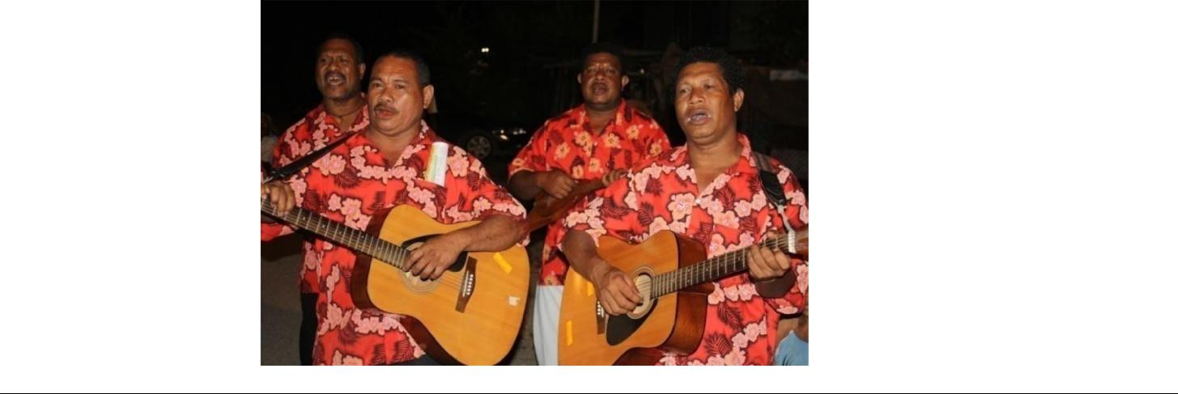
- Vision 2050

The Rationale for Vision 2050

- The lack of progress to date is largely because of:

  - the absence of long term and clear strategic actions in development plans;
  - the poor foundation inherited at independence, coupled with poor governance in later years; ²⁰

  - lack-lustre economic performance, particularly during the periods 1989 – 1990, and 1995– 2002; and

  - poor social development despite the positive economic growth experienced during 1981–1988, 1991–1994, and 2003-2008.

All of these factors point towards the critical need to chart a new development course, hence the rationale for Vision 2050.

- The basis of Vision 2050 is embedded in the Constitutional Planning Committee (CPC) Report (1974), which makes direct reference to the need for a long-term development strategy to achieve the Eight Aims. The Constitution takes up this challenge by directly institutionalising the National Goals and Directive Principles in its Preamble. The CPC Report (Chapter 2, Section 4), specifically states:

We leaders and people must know where we want to go before we can decide how we should get there. Before a driver starts a motor car, he should first decide on his destination, otherwise his driving will be without purpose, and he will achieve nothing. We Papua New Guineans are now in the driving seat. The road which we should follow ought to be marked out so that all will know the way ahead.

17. Moreover, the CPC Report (Chapter 2, Section 5) states:

Now is that historic moment in our search for identity and self-fulfilment to take the necessary measures to make substantial changes in all of our institutions, to create new ones, and to redirect development when things are fluid and tractable. But for us to know clearly what measures should be taken, our objectives must be clearly established.

- Vision 2050 attempts to ‘decide on a destination’ for Papua New Guinea in order to fulfil the dreams of our founding fathers and put the right mechanisms in place to direct this long-term development plan.

- Although the country’s forefathers had a clear vision for the nation at Independence, the journey towards achieving that vision was hampered by a lack of clear strategic actions in the ensuing

development plans. The Prime Minister, Grand Chief Sir Michael Somare, announced in October 1975 that the Eight Aims would be rather ‘clumsy’ and ‘impracticable’, if they were not actionable. ²¹ A key strategy that he called for was ‘industrialisation to advance economic development through foreign investment’.

- The challenge for Vision 2050 is to ensure that we progress the development of an overarching vision with clear, achievable strategic actions to consolidate the gains that have been made and to secure our future well-being by building internal capabilities. Papua New Guinea’s future should at least be controllable and not left to chance. The challenge, therefore, is one of arresting the recent development decline, stabilising the situation and charting a pathway that provokes and engenders sustainable growth, well into the future.

- When the World Bank reviewed development progress in the early 1980s, it noted that corrupt practices were negligible (see Berline Report).
- Samana (1988).

Why a 40-Year Vision 2050 19

- Based on our ongoing nation-building experiences, critical lessons have been learned and are now guiding the development of Vision 2050:

  - Papua New Guinea needs a vision to guide, monitor and evaluate medium term development plans over a longer period;

  - Papua New Guineans must adopt noble values, a positive attitude and learn to become powerful forces and change agents for development and nation building;

  - Papua New Guinea must set minimum standards for its institutions and systems so that their integrity is not compromised. They must be compelled and committed to continue to deliver high quality services to all citizens at all times, particularly in tough economic times;

  - having an abundance of natural resources does not make nations socially poor or prosperous;

  - race or skin colour does not make nations socially or economically poor or prosperous; and

  - the difference must be in our attitude, positive mind-sets, dedication and commitment to pursuing sustainable socioeconomic development.

- Summary

In creating the 40 year development vision, Papua New Guineans have to be smart and ensure that the Vision 2050 platform is grounded and secured in the first ten years; that is, between 2010 and 2020. Reasonable projections and key tangible outcomes must be achieved during this period in order to enhance the outcomes for 2020 to 2050. Taking into account the rapidity and nature of change taking place in this century, it is prudent to recommend that the next generation must review Vision 2050 by 2019 in order to design and set new targets for the period 2020 to2030, with ensuing reviews in 2029 and 2039.
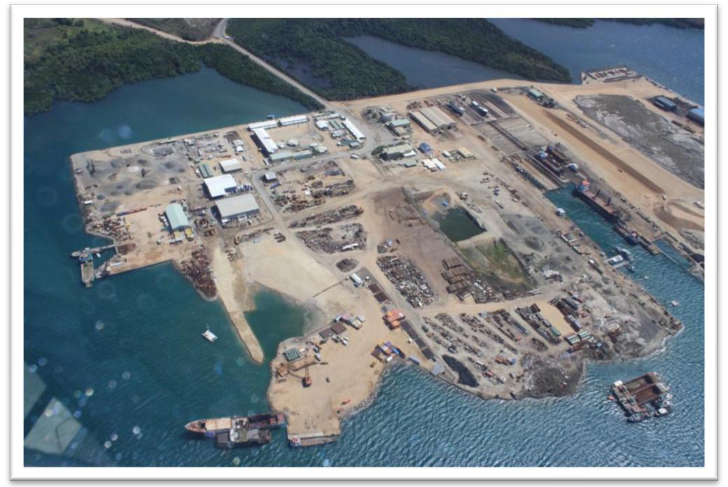
- Vision 2050

CHAPTER TWO: CURRENT SCENE AND FUTURE SCENARIOS

- Reflecting on our past experiences up to 2009 provides the basis for identification of the weaknesses, strengths, opportunities and challenges that will shape a strategic vision. Taking stock of the current economic, social and political environments, we look at possible scenarios that the country will follow, especially in the next ten years – 2010 to 2020. During this period, the problems must be fixed, reforms undertaken and the foundation set for 2020 to 2050.

- Current Scene, 2007-2009: At the macro-level, Papua New Guinea has made much progress towards arresting the decline in service delivery, political and economic stability and economic growth through wealth creation. However, it has yet to reach maturity in many aspects of government in order to ensure that systems are run on standard operating procedures (SOPs), which will lead to robust institutional development, without undue political intervention and speed up outcomes. Therefore, our challenges remain multifaceted and confront both process management issues and innovation endeavours to new emerging issues. At the micro-level, particularly in regard to service delivery and infrastructure provision, the gains in macro-management have not trickled down. This is the real challenge for contemporary PNG.

2.1 Strengths: The stability signs are encouraging.²² First, legislative reforms have improved continuity in government, with the 2002 to 2007 Government being the first to serve a full five-year term in the country’s political history. The same government is on course to complete a second full term, up to 2012. Second, economic decline has been arrested through a combination of high global commodity prices, sound macroeconomic policies and improved fiscal discipline. Third, there is now better alignment between the Government and international donor strategies through the Medium Term Development Strategy (MTDS) 2005-2010, which bodes well for long-term planning. Fourth, external relations are relatively stable.

2.2 PNG enjoys a cordial working relationship with traditional partners such as Australia and is pursuing expanded trade links with East Asia, China and India. PNG realises that its national interests could be best served by exploring growing regional markets through the Asia Pacific Economic Cooperation (APEC) Forum, the Association of South-East Asian Nations (ASEAN) Forum, and greater bilateral relationships with countries that offer the greatest potential markets for Papua New Guinea’s trade and commercial interests. In essence, some of these markets are far beyond the borders of the South-West Pacific. Fifth, because of our rich environment and biodiversity, global attention will increasingly focus on PNG during the next 40 years, as global temperature increases. Significant wealth could be gained from our environment, if it is exploited in a responsible and sustainable way. An increase in global temperature by 2 degrees Centigrade will make life on earth unbearable for many regions.

2.3 Challenges and Strategies: Contemporary PNG is currently experiencing many new challenges as well as old ones, which, if not resolved by this current generation, will haunt the next generation. An assessment of the country’s progress towards improved HDI ranking shows that, although progress towards improved real GDP per capita is highly possible in the Vision 2050 period, the real challenges will remain in the areas of improved life expectancy and school enrolment and literacy rates. Progress in these areas is contingent upon a number of factors — efficient, effective, and equitable service delivery, basic infrastructure, and job creation — particularly for youths through economic growth, equitable distribution of resources and wealth, and an overall improvement in the enabling environment for development.

- ^{See World Bank Report (2007).}

Current Scene and Future Scenarios | 21

The challenge is:

How do we ensure that Papua New Guinea’s natural wealth is exploited and primary products are processed responsibly, and that derived revenues are used equitably, transparently and efficiently to arrest service delivery decline and above all, create the foundations for employment and broad-based growth for the next 40 years and beyond?

2.3.1 Deteriorating Infrastructure: PNG enjoys substantial natural wealth and has experienced growth in total output and GDP per capita during the past six years (see Figures 3.1 and 3.2). However, with deteriorating transportation, education and health infrastructure, and increased poverty, the country has not fared well in the Human Development Index. Much of the current growth has been driven by high international commodity prices of mineral, forestry and agriculture, prudent macroeconomic management and business confidence in the private sector.

2.3.2 The bulk of the people are in the informal sector, which is dominated by subsistence and semi-subsistence activities. Economic growth has not resulted in broad-based economic development involving ordinary citizens. Therefore, income growth and distribution in PNG has been highly skewed. Basic services and infrastructure have deteriorated, as confirmed by the raw data collected by the National Strategic Plan Taskforce from the extensive country-wide district visits. Moreover, formal systems for public resources distribution and public service implementation have collapsed and are now subjected to political capture through patron-client relationships, with the increasing danger of collapsing situations reinforcing wider patron-client relationships.

2.3.3 Political Stability: Political institutions and processes are beginning to stabilise after decades of volatility and uncertainty. Although the Organic Law on the Integrity of Political Parties and Candidates (OLIPPAC) was passed in 2001 restricting post-election changes in party allegiance, there is always the danger that the OLIPPAC could be easily amended to suit political interests. If the current stability results in greater predictability, efficiency and accountability in national politics, this will be hugely beneficial for the people of PNG through Vision 2050.

2.3.4 Law and Order: A related factor to political stability is that although internal stability has improved with the return of peace in Bougainville, ‘law and order’ is perceived as a serious national issue. Law and order issues remain a threat, both in practice and perception and could undermine national interest and security. The Independent State of Papua New Guinea should reassert its monopoly of the use of force to guarantee internal security and build the basic platform for human security against natural disasters and disease patterns.

2.3.5 Vulnerability to External Shock: Papua New Guinea’s economic recovery has accelerated in recent years, with significant surpluses in the external account sufficient for at least eight months of non-mineral merchandise import cover (2007-2009). The country’s vulnerability to external shocks, such as commodity slumps, calls for the prudential maintenance of a higher level of foreign exchange than in many other countries that rely on high value-added exports. We should never repeat the experience of 1994 where, at one point, international reserves were sufficient for only one week of non-mining import cover.
- Vision 2050

2.3.6 Structure of the Economy: PNG is a resource-rich country which has substantial environmental biodiversity that can critically influence global survival. Based on these resources, the country has the potential to leverage for a 70:30 percent reorientation of the structure of the economy towards a renewable resource base, rather than its current heavy dependence on extractive industries, such as minerals and petroleum. However, Papua New Guinea’s natural resources and their contribution to economic growth remain vulnerable to governance and management weaknesses, unsustainable practices, natural disasters and biosecurity threats.

2.3.7 Public Finance Management: The application of public financial management practices is based on a sound legislative and procedural framework, but weaknesses in implementation undermine accountability and budget credibility²³ Although established systems and processes are in place, they are not always followed and breaches are not effectively penalised. The National Economic and Fiscal Commission (NEFC) notes that the lack of transparency in budget execution makes it difficult to track expenditures. A generally weakened oversighting body — the Central Agencies Coordinating Committee (CACC) — has allowed different ministerial committees to direct the flow of public finance away from budget appropriations.

The weak alignment between development and the recurrent budget, together with constricted recurrent spending means that there is a declining recurrent fund to deliver services and carry out development budget programs. The practice of ‘parking funds’ in trust accounts further diminishes budget transparency and enables a redirection of government priorities in mid-stream. Moreover, flaws in the decentralisation framework further undermine the service delivery platform that is critical to majority of Papua New Guineans.

2.3.8 Corruption: Corruption remains the biggest threat to the success of Vision 2050. PNG now ranks 151 out of 180 countries in Transparency International’s Corruption Perceptions Index (2008), compared to its ranking of 118 out of 133 countries in 2003. Inadequate capacity among oversight audit and enforcement agencies is the major cause. The systems and processes are not the problems; it is the increasing lack of widespread respect and compliance within the community and leadership level. The continued freedom of the press in PNG has ensured that there is a significant and growing demand for good governance.

2.3.9 Policy Lapses: Policy lapses over the past two decades have resulted in 53 percent of the country’s population now (2009) living below the national poverty line. In this sense, poverty is largely a rural phenomenon for 85 percent of the population. To complicate things, approximately 55 percent of adults remain illiterate and therefore have no input into the country’s formal systems. Failure to adopt an inclusive development and people-centred socioeconomic empowerment strategy to lock in this segment will result in problems of unimaginable proportions.

2.3.10 Working-Age Population: An estimated six percent of the working-age population in PNG are employed in the formal sector (2002), compared to Solomon Islands (9%) (2002), Vanuatu (15%) (2004), Fiji (25%) (2003), and Samoa (63%) (2001). With a population growth of 2.7 percent per year, the job creation challenge becomes mission critical, particularly because of the link between youth, limited educational opportunities, unemployment and lawlessness. By 2050, Papua New Guinea’s population is expected to be approximately 18 million. Relevant education and job creation, therefore, should be the government’s strategic and political priority.

- ^{World Bank 2007.}

Current Scene and Future Scenarios | 23

2.3.11 Small-Scale Manufacturing: Agriculture, fishing, community forestry, artisanal and small-scale manufacturing and mining are important sources of subsistence and cash income in rural PNG. Income-earning opportunities through micro, small and medium enterprise development ventures are constrained by an unfriendly investment climate, and absence of entrepreneurial and relevant technical and managerial skills. There are about 100 000-120

- micro-enterprises, 12 000-15 000 small businesses, and 3 000-3 500 medium enterprises that need to evolve into the formal sector.²⁴ Somewhere between 250 000 and 500 000 people participate in coastal subsistence fisheries and a similar number benefit from artisanal and small-scale mining and manufacturing activities.

2.3.12 Subsistence agriculture and forestry ventures play a critical role in enhancing rural livelihoods and the cultural lives of many. Expansion of these income-earning opportunities is hampered by limited and expensive access to inputs and markets, poor infrastructure, ineffective extension services, limited access to credit and safety and security concerns. The World Bank (2009)²⁵ ranks PNG 95 out of 183 economies, which is down from 84 out of 178 economies in 2008, in terms of ‘doing business’.

2.3.13 Conducive Business Environment: The tariff reduction program and other structural reforms were introduced in 1999. However, the Government and its responsible agencies have been slow in facilitating a conducive business environment to overcome the following issues:

- the law and order situation leading to high security and insurance costs;
- poor infrastructure, particularly transport infrastructure;
- high transportation costs, especially coastal shipping and airlines;

- ineffective customs services;
- high utility costs; and
- unfavourable pricing arrangement for certain inputs, such as fuel products.

2.3.14 Trade liberalisation, preceded by domestic structural reforms, will result in lowering the cost of doing business and will lead to efficiency and higher productivity. Local industries, and the manufacturing industry, in particular, have been vocal about this. This is a challenge that needs to be urgently addressed.

2.3.15 Access to Health Services: Health outcomes have lagged far behind accepted standards in the past decade. The serious threat of HIV/AIDS combined with a faltering health system, flags severe consequences. Government sources estimate that 1.28 percent of the population is living with HIV/AIDS (2007).

2.3.16 Access to Education: Access to education has improved marginally. More improvement is required, not only in terms of accessibility, but also in terms of quality, efficiency and equity. Arising from the 1993 national education reform, enrolment rates have tripled and have outstripped educational resources and institutional capacity. Gross enrolment rates have remained at 75 percent, which is well short of the goal of Universal Basic Education (UBE). Girls account for some 45 percent of enrolments in the basic education cycle, but their proportion drops to 40 percent by Grade 10, and 35 percent by Grades 11 and 12. Literacy rates among youths are low at 67 percent.

- See Kavanamur (2002).

- The World Bank’s ‘Doing Business Report’ provides objective measures of business regulations and their enforcement across 183 economies and selected cities at the subnational and regional level (http://www.doingbusiness.org/features/Highlights2010.aspx).
- Vision 2050

2.3.17 Service Delivery: Given service delivery complexities, progress towards the Millennium Development Goals targets will certainly remain out of reach, well beyond 2015, unless the basic platform for arresting the decline in service delivery, infrastructure and income distribution is laid, during the first ten years of Vision 2050. Political will is critical for service delivery.

2.3.18 Gender Inequalities: Significant gender inequalities remain a concern in PNG. However, there is a high possibility that the National Parliament will approve seats for women, commencing in 2012. At the Vision 2050 Leaders’ Summit in Lae, Morobe Province, on 14-16 August 2009, provincial governors, together with the Prime Minister, Grand Chief Sir Michael Somare, resolved to endorse the proposal to have women’s seats.

2.3.19 Increasing Youth Population: PNG faces a challenging future if it does not seriously address the education and employment demands of an increasing youth population. Approximately 50 percent of the population is under 20 years of age and this proportion is expected to increase dramatically in the next twenty years. The development of special youth programs, such as education, vocational training, community development programs and economic empowerment, should be considered as mission critical.

2.4 Opportunities: Against the backdrop of these formidable challenges, considerable opportunities for progress are available to Papua New Guinea to arrest the decline in human development outcomes, stabilise the situation and grow the economy for future prosperity through Vision 2050. A key opportunity exists to adopt a ‘focus’ strategy on resource and manufactured-based exports to ensure that it is accountable and sustainable and brings strong initial growth between 2010 and 2020. Once there is strong growth in the extractive industries and the renewable resource-based exports, it is critical to use the income to diversify the economic base.

2.4.1 Opportunities exist in food production for the domestic market, high value export crops, developing import-competing industries and plantation forestry while preserving ancient forests. These are also opportunities in downstream agro-industry, small-scale and light manufacturing, tourism and the service industry.

2.4.2 Artisanal and small-scale economic activities in fishing, mining and village-based forestry are also good prospects. Improving the investment environment and adopting economic corridor planning across the country will greatly promote the non-mineral sector and drive social and economic growth. In this regard, land reform will be critical. Ensuring that there is accompanying good governance and sound public financial management will ensure that there is equitable economic growth and efficient service delivery.

2.5 Future Scenarios: Given the qualitative and quantitative data which indicate the status of the present socioeconomic situation, one can extrapolate different future scenarios. The qualitative data paint a picture that, if the status quo prevails for a few more years, then major social upheavals can be expected, as existing social safety nets which are based mainly on the wantok system, are overstretched, as average household sizes range between 10 and 20 members.

Current Scene and Future Scenarios | 25

2.5.1 There is an increasing sense of despair within rural and urban communities, as access to services dwindle and economic opportunities for the youthful population become evasive. Vision 2050’s district consultation data indicate that people have lost confidence in the system which is supposed to deliver services on their behalf. The rural populace’s confidence in the education system, as a ticket for job opportunities, is on the wane because the educational highway for many ends at Grade 8. There is an acute awareness of the increasing divide between urban and rural areas, in favour of urban dwellers, with an emerging perception of a ‘them versus us’ scenario. There were open discussions about how rural wealth is being siphoned off to urban communities for their use, at the expense of rural and remote dwellers.

2.5.2 Anti-foreign ownership sentiments are rising because of their dominance of business, which is creating an entrepreneurial gap between locals and immigrants. Amongst the older generation, was heard a nostalgic longing for the ‘gut taim bipo’, when the ‘colonial masta’, through the kiap system, delivered services and infrastructure with little manpower and money. Through the many consultations, villagers expressed the view that all they needed was for the national government to just send them the money so that they could conduct their own service delivery, using mainly the churches, their own labour and other community-based organisations.

2.5.3 What must be done during the next ten years (2010 – 2020) to arrest and stabilise the situation? The State will require strategic planning, better service delivery and improved governance. Furthermore, identification and training of human capital, tariff reduction, increased trade, education reform and implementation, downstream processing and manufacturing and land reform must be undertaken. Impact projects in the 89 districts must also be carried out to build the base for growth during 2010 to 2020 and set the foundation for future years.

2.6 Four Possible Pathways for the Economy: There is always uncertainty when we look into the future.

To account for this, four economic scenarios are provided on the possible paths the Papua New Guinean economy should take from 2010 to 2020 in relation to economic growth, supported by the seven Strategic Focus Areas of Vision 2050:

- the Base Case;
- Land Reform;

- Liquefied Natural Gas (LNG) Project; and
- Cumulative Scenario.

The Base Case is the minimum growth path possible. If either the land reform agenda or the Liquefied Natural Gas project is implemented, or if both are implemented, each will add incremental and transformational benefits to the base path. The cumulative scenario is one where all the activities of the first three scenarios take place simultaneously; that is, one that combines the effects of the other three scenarios.

2.6.1 Base Case Scenario: A 2009 National Research Institute (NRI) study projected that, from 2010 to 2020, the Papua New Guinean economy will grow by two percent in real terms per year. This growth rate is possible through human resource development, the development of new technologies and adoption of more efficient production methods and downstream processing. It takes into account the schedule of declining oil reserves up to 2013, moderate recovery in the global economy between 2010 and 2013 from the current global recession, recovery in oil production after 2013 and the World Bank’s projections on commodity prices. Vision 2050 will emphasize economic growth and wealth creation through downstream processing, enhanced manufacturing activity, improved infrastructure, delivery of goods and services, increased
- Vision 2050

interconnectivity and increased trade. This would result in an average increase in growth from two percent to 4.5 percent in real GDP per year. Downstream processing in forestry, agriculture and fishing alone can add significant value to Papua New Guinea’s GDP.

2.6.2 In cumulative aggregate terms, Papua New Guinea’s real GDP will rise from an estimated K8.9 billion in 2008, to K15.1 billion by 2020. This does not include the LNG project and any other policy initiatives. Per capita income should be K1 819.60 by 2020.

2.6.3 Land Reform (with Base Case) Scenario: With the inclusion of the implementation of ‘land reform’, the economy can grow by an additional 1.2 percent in real terms each year (moderate impact), if some three percent more of total customary land is brought into production in the formal sector. Cumulatively over the years, this will translate into an additional K3.0 to K4.5 billion to the GDP (in addition to the K15.1 billion in the Base Case), by 2020. Total real GDP will be approximately K18.5 billion by 2020. Underpinning this improvement will be broad-based higher investment and exports and consumption in the non-mineral sectors such as agriculture, forestry, fisheries, manufacturing and services. Per capita income is projected to reach K2 220 by 2020.

2.6.4 LNG Project (with Base Case) Scenario: With the inclusion of the Liquefied Natural Gas project, Papua New Guinea’s real GDP growth will be even higher. It has been estimated that real GDP per year will be K18.2 billion, which is approximately K9 billion above current annual GDP²⁶. A more conservative incremental increase estimate of K5 billion per year, on average, is taken. Real GDP will reach K20.1 billion by 2020. Per capita income is projected to reach K2 420.50 by 2020.

2.6.5 Cumulative Scenario (with Base Case, Land Reform and LNG Project): This is the scenario where land reform and the LNG project occur simultaneously with the Base Case. It is the most desirable scenario, as the benefit streams from both land reform and the LNG project accrue because of a concerted effort to start land reform by 2010 and the LNG project to commence production by 2014. It is in the national interest for this scenario to be pursued, as it will yield a real GDP of K23.5 billion by 2020. Per capita income is projected to reach K2 820.90 by 2020 (see Figure 2.1). This scenario does not take into account the contributions of new mining, petroleum and gas projects that have already commenced or may come on-stream during this period.²⁷

2.6.5.1 By 2020, Papua New Guinea’s real GDP is projected to reach between K15 billion and K24 billion, and per capita income to be between K1 820 to K2 820. Figure 2.1 shows the projected level of real GDP for 2010, 2015 and 2020 under the four scenarios. If land reform is undertaken in 2010, real GDP will improve from K9.7 billion to K12.5 billion, which is an increase of K2.8 billion. While the LNG project would provide a huge funding relief to the Government of Papua New Guinea (GoPNG) in its efforts to stabilise service delivery and infrastructure development, Vision 2050 insists that, as a matter of strategy to reduce the incidence of poverty right across the country and improve HDI, decision makers should not relent in their push for land reform, as the multiplier effects of such a reform would reverberate throughout the country past the life-span of the LNG project. To leverage the strategic thrust of Vision 2050 towards the renewable sector (70:30 ratio) it is critical that land reform should commence in the first ten years, with further progress to be made in the remaining 30 years of Vision 2050.

- (ACIL Tasman 2008)

- At the time of the drafting of Vision 2050, information on InterOil’s proposed (LNG) Elk/Antelope project were yet to become available. Thus, the project is not explicitly mentioned. It is, however, acknowledged that growth in economic activity and benefits could be far greater than the figures discussed here if this and any other projects come on stream in this period.

Current Scene and Future Scenarios | 27

Expected Real GDP under different scenarios

Kina in million

25,000.00
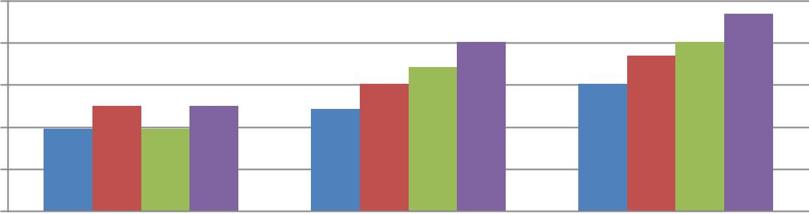

20,000.00

15,000.00

10,000.00

5,000.00

-

year | 2010 | 2015 | 2020

Scenario 1 - Base case

Scenario 2 - Land reforms with Base case

Scenario 3 - LNG with Base case

Scenario 4 - Comprehenseive - Base case, Land reform and LNG

Figure 2.1: Real GDP Growth Scenarios, 2010-2020

Source: Vision 2050: Core Technical Team's Calculation/Extrapolation using NRI’s Study (2009) and the ACIL Tasman Study (2008).

2.6.5.2 Table 2.1 shows the desired paths of real GDP and per capita income that Vision 2050 will aspire to achieve. It should be noted that while Vision 2050’s projections are conservative, because of the need to have realistic estimates for the period, 2010-2020, the assumptions will need to be revised by a Vision 2050 review team in 2019, to take into account new mine developments, commodity price changes, the effects of climate change and other external shocks. The assumed population growth rate is 2.5 percent, which is the average between 2.3, and 2.7 percent. This appears to be an acceptable rate of growth because, over the next 40 years, at ten year intervals, population growth is expected to decline as a result of the effects of HIV/AIDS and other pandemics, the rise in global temperature of between 2 to 6 degrees Centigrade and associated risks, the degree of affluence and education amongst families and adherence to a national population policy.
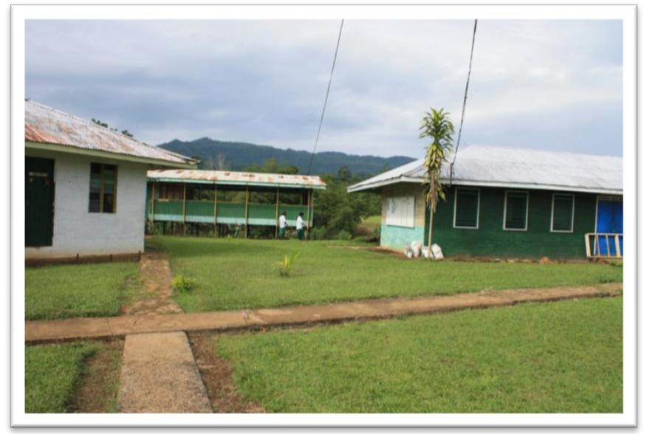

- Vision 2050

Real GDP (K’million-1998 Kina) |  |  |  |  | Population | Per Capita Income (Kina)
Year | Base- | Land | LNG with | Cumulative | (2.5% | Base- | Land |  | LNG with | Cumulative
 | Case | Reform | BC | with BC and | growth) | Case | Reform |  | BC | with BC, LR,
 |  | with BC |  | LNG | growth) |  | with BC |  |  | and LNG
2010 | 9 749.1 | 12 478.8 | 9 749.1 | 12 478.8 | 6 500 000.0 | 1 499.9 | 1 919.8 |  | 1 499.9 | 1 919.8
2015 | 12 149.2 | 15 182.4 | 17 149.2 | 20 182.4 | 7 354 153.4 | 1 652.0 | 2 064.5 |  | 2 311.9 | 2 744.4
2020 | 15 140.1 | 18 471.1 | 20 140.1 | 23 471.7 | 8 320 549.5 | 1 819.6 | 2 220.0 |  | 2 420.5 | 2 820.9
2025 | 18 867.3 | 24 719.4 | 28 247.5 | 34 387.7 | 9 413 938.1 | 2 004.2 | 2 625.8 |  | 3 000.6 | 3 663.5
2030 | 23 512.0 | 33 080.1 | 39 618.5 | 50 673.7 | 10 651 006.9 | 2 207.5 | 3 105.8 |  | 3 719.7 | 4 757.6
2035 | 29 300.3 | 44 268.6 | 55 567.0 | 74 456.3 | 12 050 636.6 | 2 431.4 | 3 673.5 |  | 4 611.1 | 6 178.6
2040 | 36 513.5 | 79 278.3 | 109 308.8 | 160 745.7 | 15 425 833.7 | 2 949.8 | 5 139.8 |  | 7 086.1 | 10 420.5
2050 | 56 704.3 | 106 092.3 | 153 311.2 | 236 188.1 | 17 452 914.9 | 3 249.0 | 6 078.8 |  | 8 784.3 | 13 532.0

Table 2.1: Four-Pronged Projected Economic Scenario, 2010-2050

Note:

- Base Case assumes a 4.5 percent growth rate based on the experience of the past seven years and that initiatives in the seven pillars will sustain this rate of growth, including downstream processing in agriculture, forestry, and fishing.

- The Land Reform scenario assumes a desired growth rate of six percent after 2020. From 2010 to 2020, the NRI study is used.

- The LNG scenario assumes a desired growth rate of seven percent after 2020. From 2010 to 2020, the ACIL Tasman study is used.

- Under both the Land Reform and the LNG project, a desired rate of eight percent is applied after 2020.

Source: NSP Core Technical Team’s Calculation/Extrapolation (2009) using the NRI Study and the ACIL Tasman Study.

2.6.5.3 The scenarios presented in Chapter 3 show an array of possibilities for PNG to attain its stated Vision 2050 economic, social and welfare targets. PNG aspires to improve its HDI from the current ranking of 148 out of 182 countries (2009). The desired progressive rankings are 123 by 2020; 98 by 2030; 73 by 2040, and 50 or better by 2050 (see Table 2.2).

2.6.5.4 PNG aspires to progressively improve its life expectancy from the current 57.9 to 77 years of age or better, by 2050. The basic education gross enrolment rate is projected to increase from 85.5 percent in 2010 to 100 percent in 2050.

Year | Human | Life | Real per | Adult Literacy | Basic Education
 | Development Index | Expectancy | Capita GDP | Rate (percent of | Gross Enrolment
 | (HDI) (out of 182 | (years) | (Kina) | 15 years and | (pre-Gr. 8, 6 – 14
 | listed countries) |  |  | older) | year pop.)
2010 | 148 | 58.0 | 1 919.8 | 58 | 85.5
2020 | 123 | 63.0 | 2 744.4 | 70 | 90.0
2030 | 98 | 68.0 | 3 663.5 | 80 | 96.5
2040 | 73 | 72.0 | 6 178.6 | 90 | 98.0
2050 | 50 | 77.0 | 10 420.5 | 100 | 100.0

Table 2.2: Strategic Target Goals for Vision, 2050

2.7 Economic growth under the four described scenarios will provide the means for the Government to deliver on its seven pillar activities. In turn, improved infrastructure, human resource development, improved health and educational facilities and institutions and improved life expectancy will empower the people of Papua New Guinea, to be wise, fair, smart, healthy and happy.
Current Scene and Future Scenarios | 29

- Summary

The lack of good governance, accountability and transparency has contributed to the deterioration in the delivery of public goods and services at the micro-level. Over the past six to seven years, there has been an improvement in macroeconomic management, which, together with the high international commodity prices have led to growth and stability in the economy. Infrastructure in the broad sense must be improved to enhance accessibility and service delivery to bring improvement to remote, rural and urban communities.

We simply do not have any more excuses. We owe it to ourselves and the future generations to shift our attitudes and mind-set towards improving our living standards. We are faced with an array of challenges, but we are also presented with great opportunities. The four scenarios that have been described give direction to possible ways in which we can now progress in earnest to have an impact on the lives of our people. PNG must strive for a future that is underpinned by the cumulative economic growth of all four scenarios — one that takes into account the Base Case (4.5%), Land Reform (6%), LNG project (7%) and cumulative scenario (8%) as a way to achieve our Vision 2050.
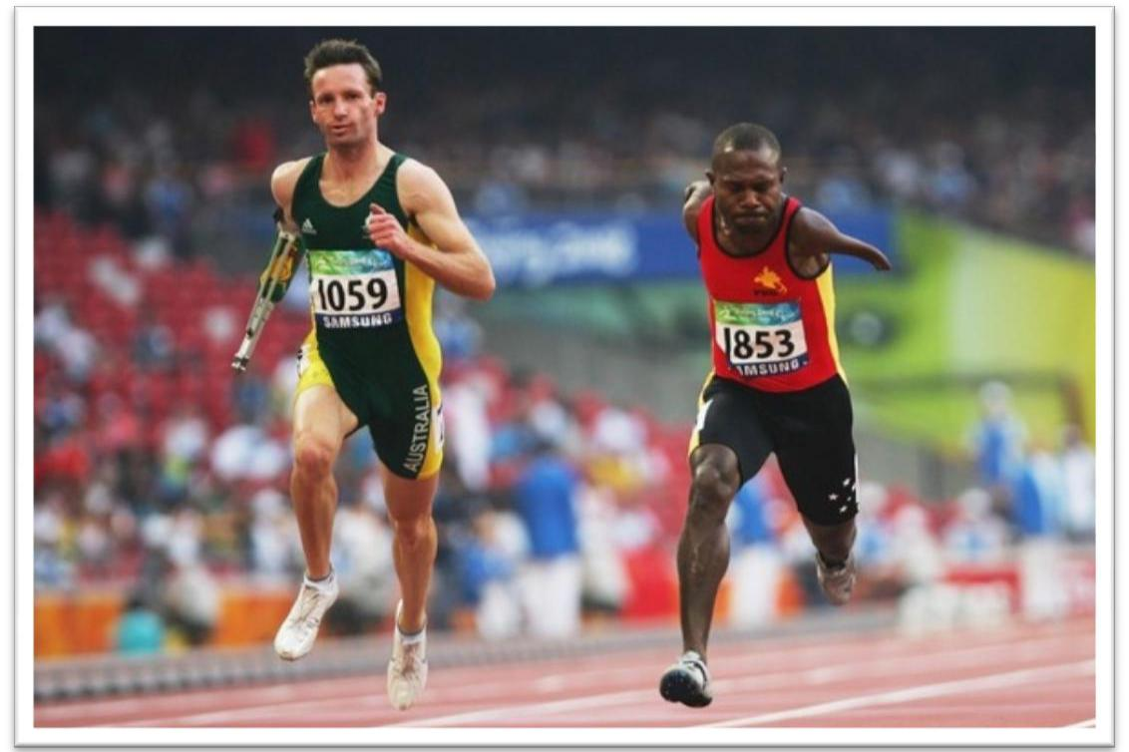
- Vision 2050

2.1.5
2.1.6

CHAPTER THREE: VISION 2050

- Our Intention: Vision 2050 will transform our people and our nation by reforming our mind-set and attitudes. It is envisaged that this, will provide the direction to reform and align our institutions and systems to make ‘Papua New Guinea become a smart, wise, fair, healthy and happy Society by 2050’.

- Aims of Vision 2050: Vision 2050 aims to achieve this through effective service delivery, human resource development, wealth creation and sustainable development of our existing vast natural resources which are underpinned by our shared national interests. Our national interests revolve around security, prosperity and values.

2.1 Vision 2050 reaffirms and integrates the key outcomes of ‘Papua New Guinea’s Eight Point Improvement Plan’ with an additional outcome related to competitive trade positioning:

2.1.1 The people of Papua New Guinea to play a greater role in the economy;
2.1.2 Equality among people and areas;

2.1.3 Much greater attention to rural and balanced regional development through effective service delivery;
2.1.4 Serious attention to acquire characteristics of a fast developing country by shifting

economic activity from primary to manufacturing, service and knowledge economies; Self-reliance; and

Progressive and global competitiveness.

3. The Framework: Vision 2050 is derived from the National Strategic Plan Framework²⁸ that was endorsed by the Government and national leaders in September 2008. The concepts and strategic direction in the framework were rigorously tested during a three-month comprehensive public consultation program in which the 89 districts were visited. Vision 2050, therefore, is the formalizing

of many citizens’ dreams and aspirations of building a better Papua New Guinea for ourselves, our children and our grandchildren.

- Our Vision and Mission Our Vision:

‘We will be a Smart, Wise, Fair, Healthy and Happy Society by 2050.’

4.1 Being smart means to encourage and reward excellence, innovation and relevance.

4.2 Being wise means that our people, our institutions and our systems will practise and uphold transparency, accountability and good governance. Our people and leaders will consistently make the right decisions.

4.3 Being fair means that our people, our institutions and our systems will equitably distribute resources and opportunities.

4.4 Being happy means our people will be healthy, wealthy and safe.

- Final Report to National Development Summit, 2008

Vision 2050 | 31

4.5 Based on the development analysis of the past three decades and following the comprehensive district consultations, we believe that the best way to achieve Vision 2050 is through embracing our National Goals and Directive Principles.

- Our Mission Statement

5.1 ‘We will be ranked in the top 50 countries in the United Nations Human Development Index by 2050, creating opportunities for personal and national advancement through economic growth, smart innovative ideas, quality service and ensuring a fair and equitable distribution of benefits in a safe and secure environment for all citizens’.

- Our Values and Guiding Principles: Our people are the most valuable resources in our development aspirations and ongoing nation building efforts. We value ‘Integrity, Excellence, Discipline and

Christian Values-Based Leadership’ and will strive to uphold these attributes at all times.

6.1 Vision 2050 embraces the five National Goals and Directive Principles contained in the Constitution as our guiding principles:

6.1.1 Integral Human Development;
6.1.2 Equality and Participation;
6.1.3 National Sovereignty and Self-Reliance;
6.1.4 Natural Resources, Resource Creation and Environment; and

6.1.5 Papua New Guinean Ways

- The Strategic Direction: Currently, our economy is dominated by the mining and energy sectors. It is estimated that these sectors contribute some 80 percent of our total export revenue.

7.1 The strategic direction for Vision 2050 is that ‘Papua New Guinea will develop and grow the manufacturing, services, agriculture, forestry, fisheries and tourism sectors from 2010 to 2050’. This direction will ensure that economic growth by 2050 will be broad-based and disposable household incomes will be much higher than at present, resulting in an improvement in our HDI ranking.

8. Strategic Focus Areas: Vision 2050 will focus on seven ‘Strategic Focus Areas’, from 2010 to 2050 (see

Figure 3.1):

8.1 Human Capital Development, Gender, Youth and People Empowerment;
8.2 Wealth Creation;
8.3 Institutional Development and Service Delivery;
8.4 Security and International Relations;
8.5 Environmental Sustainability and Climate Change;
8.6 Spiritual, Cultural, and Community Development; and
8 7 Strategic Planning, Integration and Control.
- Vision 2050

- Key Assumptions: The successful delivery of Vision 2050 is dependent on ten key assumptions:

9.1 Political stability is strengthened and there is consistency in government policies, and sustained political will;

9.2 The current bureaucracy is not threatened by the likely changes that will occur; instead it will support and facilitate the programs in Vision 2050;

9.3 There is no change or only minimal changes to the Base Case scenario, which anticipates a real GDP growth of 4.5 percent over the first ten years;
9.4 The government improves governance and reduces corruption;
9.5 The government systems and institutions are reformed and aligned to Vision 2050;
9.6 All key stakeholders support Vision 2050 and make the necessary paradigm shifts;

9.7 The Government develops a Public Services Training Package and National Qualification Framework to derive an intelligent, durable and performance-oriented public service;

9.8 The Government develops an effective information and communication strategy for Vision 2050;
9.9 There is effective risk management and strategic control; and
9.10 The Government will adequately resource and fund Vision 2050 programs.

- Vision 2050: Vision 2050 is supported by seven ‘Strategic Focus Areas’ or development pillars, with strategic planning as the central and coordinating function. The seven focus areas that have been developed in Vision 2050 will become the basis on which development plans from 2010 to 2050 will be anchored. The strategy that follows translates these focus areas into a statement of achievable objectives and serves as a framework from which sectoral plans are prepared and implemented in a logical and sequential manner, instead of the ad-hoc approaches that have been experienced so far.
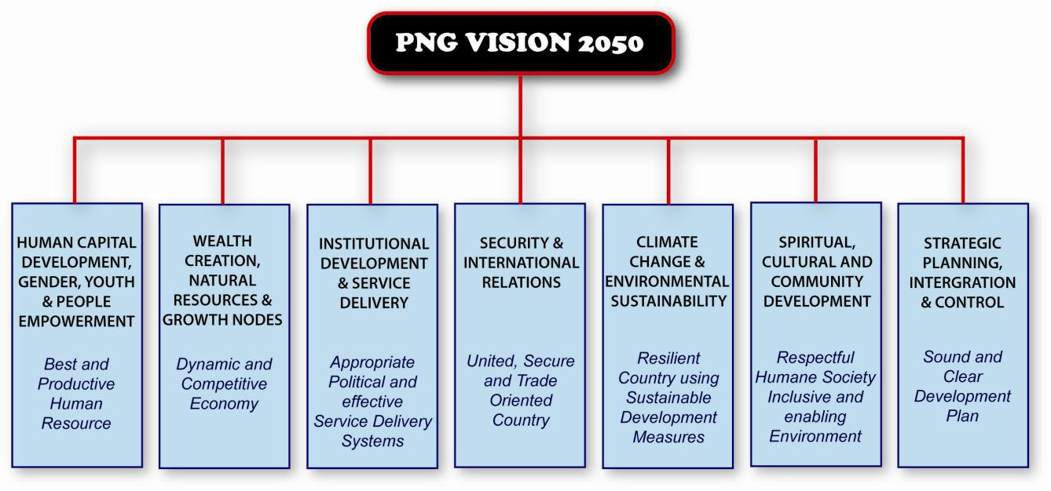

Figure 3.1: The Seven Strategic Focus Areas of Vision 2050
Vision 2050 | 33

- Human Capital Development, Gender, Youth and People Empowerment: Papua New Guinea’s future success depends on the quality of its human resources. Vision 2050 is aimed at producing citizens who are healthy and intellectually astute, and have high ethical and moral character and attitudes. Our people must be developed and empowered to take ownership of their own livelihoods. Excellence and innovation must be recognised and rewarded. A study made by the OECD indicates that a rise in the

expenditure on human resources by ten percent leads to an increase in output per capita between four and seven percent. ²⁹ Experiences from countries with limited natural resources show that huge investments in human capital development result in massive and integrated socioeconomic development.

11.1 Papua New Guinea’s population is growing at an annual rate of between 2.3 and 2.7 percent, with approximately 55 percent of the population unable to read and write. Access to basic education and health remains below acceptable levels because of a lack of physical infrastructural development, among other factors. The gender gap on access to education, and drop-out rates continue to be our challenges. Immediate strategies to arrest further decline in all social indicators must be adopted.

11.2 Based on extensive consultations and discussions with stakeholders throughout PNG, a clear consensus has emerged to suggest changes to our existing systems, structures and processes in order to improve access to education. Enrolments in Grades 9 to 12 have remained low, with more than 50 percent of students dropping out at the end of Grade 8. Grade 12 attrition and completion rates have been below 30 percent, with 70 percent of students leaving school between Grades 9 and 11. These prevailing trends in enrolments and completion rates must be changed by 2015 to ensure that all Grade 8 students progress to Grade 12.

11.3 Efforts must be made to further improve and increase access to education from Elementary to Grade 12. Since 1993, Elementary to Grade 8 enrolments have increased by 360 percent. This has increased the enrolment rate to 81.5 percent in 2008. Vision 2050 aims to achieve 100 percent enrolment by 2050.

11.4 There is a need to improve and increase access to the national high schools to produce students who will be trained in science subjects, such as chemistry, biology, physics, geology, marine and environmental sciences, mathematics, English and be competitive in bidding for scholarships to study in Papua New Guinea and at overseas higher education institutions.

11.5 The public and private sector both highlight the need to improve and increase access for technical and business training colleges. The annual enrolment into technical and business colleges is approximately 800 students, which is only seven percent of the 12 000 Grade 12 school leavers each year. Current enrolment in the colleges is less than 2 500, with a graduate output of less than 1 000 annually. This represents 13 percent of all tertiary enrolments. To decrease the drop-out rate at the end of Grade 12 and improve the competence of our human resource, technical or polytechnic colleges must be established in each province by 2020.

- OECD: The Well-Being of Nations: The Role of Human and Social Capital. OECD Publishing 2001.
- Vision 2050

11.6 Access to university education and graduate programmes should be enhanced. In the tertiary education sector, current university enrolment is approximately 10 000, which is 55 percent of tertiary enrolments. In 2009 two of our six universities are run by the churches. The current annual enrolments and graduate outputs of less than 2 000, are inadequate to match the demand that is being created by new investments and an ageing work force. It is imperative that university enrolments and graduate outputs are increased to 50 percent by 2020.

11.7 There is a need to increase, improve and support current research-based institutions and universities in order to produce top quality research and development outcomes that will provide solutions to challenges in areas such as medicine, climate change and disease patterns. Existing Institutions — especially universities — must engage in fostering alignment and partnerships to integrate research and development with teaching and learning which will enhance the quality of education. It is also necessary to establish an Industrial Technology and Development Institute (ITDI) to promote research aggressively and cooperatively amongst institutions of higher education.

11.8 Access for all education levels through open, flexible, and distance education (OFDE) should be improve and increased. Currently, the University of Papua New Guinea, the Papua New Guinea University of Technology and the Department of Education offer courses from high school and secondary school certificate level to degree-level programs. A few other private providers also offer a variety of courses. Through OFDE, the current drop-out rates at Grades 8, 10, and 12 can be significantly reduced. Therefore, an OFDE Commission should be established to maximise the use of this modality by 2020.

11.9 Extensive consultations throughout the country indicated that there is an overwhelming dissatisfaction with the newly introduced Outcome-Based Education (OBE) curriculum. Parents and teachers have revealed that the quality of learning and teaching has been greatly compromised by OBE. Students from Grade 6 through to tertiary education level have difficulty in expressing themselves in the English language. The consultations observed that Elementary 1 and Elementary 2 teachers are under qualified. It was also revealed that teachers are currently overworked because of the demands imposed on them by the teaching methodology prescribed by OBE. It is imperative that OBE is immediately replaced with a curriculum that offers a balanced education, using English as the medium of instruction, starting in Elementary 1, as soon as possible.

11.10 The quality of teacher education with subject specialisations needs to be improved in order to deliver quality education. Teachers’ salaries and conditions must also be improved to encourage and increase employment in a teaching career.

11.11 An independent National Curriculum, Assessment and Monitoring Authority (NCAMA) should be established to monitor the quality of education and training. The quality should equate to international standards and be commensurate with the demands of the economy.

11.12 To maintain educational funding, an Education Endowment Fund (EEF) must be established to ‘park’ all funds that are appropriated by the National Parliament from the Public Investment Budget Strategy. The EEF will sponsor and fund national and overseas scholarships.

Vision 2050 | 35

11.13 There is a need for social capital development within communities. Social capital refers to the shared norms or values that promote cooperation and cohesion within, and among, social relationships within a community or setting.

11.14 Literacy is the basis for basic skills and knowledge for all individuals. It is therefore important to establish community colleges throughout the country to improve and increase access to basic literacy and other life-skills training.

11.15 Women comprise some 50 percent of the country’s population, but are underutilised. At present, women comprise some 30 percent of the work force, fewer than 40 percent of the combined gross enrolment ratio for primary, secondary and tertiary education, and 50.9 percent of literate adults aged 15 and older. There are very few women in management, leadership, and decision-making roles in the workplace. The Gender–Related Development Index (GDI) ranks PNG 124 out of 177 countries, with a GDI of 0.529 (UNDP 2008).³⁰ Greater participation of women must be encouraged at all levels of society.

11.16 Current demographics indicate that 40 percent of the population are youths. This presents a huge potential for collective wealth creation and development. Therefore, programs and systems must be improved and expanded to encourage greater participation from youths in all organisations and institutions, and in development programs.

11.17 Systems to address the current, persistent, socioeconomic inequalities must be funded and established to eradicate poverty and reduce disparities in income, provincial and district, employment and asset and wealth. There is also a need to bridge the digital and technology divide. Vision 2050 sets the basis for political will and directs appropriate agencies to reduce the widening gap in socioeconomic inequalities.
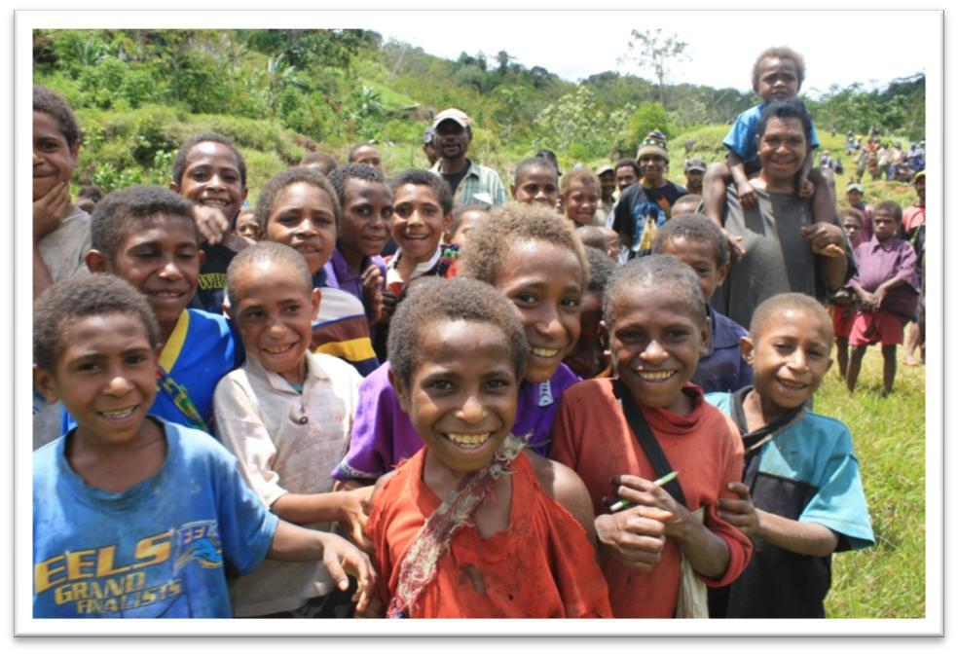

- GDI measures average achievements to reflect inequalities between men and women in life expectancy, knowledge (as measured by adult literacy rate and the combined primary, secondary and tertiary gross enrolment ratio), and a decent standard of living, as measured by estimated earned income (the Purchasing Power Parity is in US$).
- Vision 2050

 | Objective |  |  |  | Priority Activity |  |  | Key Outcomes |  |  |  | Key Performance Indicators |  |  | Means of Verification
 | Train and empower |  |  | • | Provide easy and |  | • | The education system |  |  |  | • | Local and international |  | • | National and
 | citizens to become |  |  |  | affordable access to |  |  | is world class. |  |  |  |  | acceptance of our |  |  | international
 | powerful forces for |  |  | • | education to all citizens. |  | • | Universal primary |  |  |  | • | education system. |  |  | reports on
 | development and |  |  | • | Provide equal |  | • | education is achieved. |  |  |  | • | All school-aged children |  | • | education.
 | nation building. |  |  |  | employment |  | • | Enhanced gender parity |  |  |  |  | are enrolled in primary |  | • | Performance report
 |  |  |  |  | opportunities for all |  |  | and equality in access to |  |  |  |  | education. |  |  | on the Millennium
 |  |  |  | • | citizens. |  |  | formal education. |  |  |  | • Gender distribution in the |  |  | • | Development Goals.
 |  |  |  | • | Invest in knowledge |  | • | People are empowered, |  |  |  | • | education system. |  | • | National and
 |  |  |  |  | industry and |  |  | innovative, and |  |  |  | • | Higher education |  |  | international
 |  |  |  |  | technological |  |  | knowledgeable. |  |  |  |  | institutions are world |  |  | reports on gender
 |  |  |  | • | advancement. |  |  |  |  |  |  |  | standard. |  |  | and education.
 |  |  |  | • | Support and enhance
 |  |  |  |  | community
 |  |  |  |  | empowerment
 |  |  |  |  | initiatives.
 | Widening access and |  |  | • | Provision of accessible |  | • | Increased human |  |  |  | • | Increase from current |  | • UBE to 100 percent.
 | enhancing equity. |  |  | • | learning institutions. |  | • | capacity output. |  |  |  |  | eight percent human |  | • | Gender and
 |  |  |  | • | Incentives to enhance |  | • | Increased enrolment |  |  |  | • | capacity to 30 percent. |  |  | regional equity.
 |  |  |  |  | equity. |  | • | rate |  |  |  | • | Increased Gross Enrolment
 |  |  |  |  |  |  | • | Non-discriminatory laws |  |  |  | • | Rate to 98 percent
 |  |  |  |  |  |  |  | and policies. |  |  |  | • | Increased gender
 |  |  |  |  |  |  |  |  |  |  |  |  | participation.
 | Improving the quality |  |  | • | Improved quality of |  | • | Internationally |  |  |  | • | Quality graduates and |  | • | International
 | of teaching and |  |  |  | learning materials. |  |  | compliant and |  |  |  |  | technocrats. |  |  | standards.
 | learning. |  |  | • | Improved quality of |  | • | compatible curricula |  |  |  | • | Improved basic |  | • | Quality assurance
 |  |  |  | • | teachers and academics. |  | • | Improve teacher |  |  |  |  | qualification for all |  | • | monitoring boards.
 | Enhancing research |  |  | • | Rehabilitate, convent |  |  | education capacity and |  |  |  | • | teachers at graduate level. |  | • | Internationally
 | and innovation. |  |  |  | and expand existing |  | • | quality. |  |  |  | • | 50 research science |  |  | acclaimed research
 |  |  |  |  | institutions and facilities |  | • | Create centres of |  |  |  |  | engineers per 10 000. |  |  | institutions.
 |  |  |  |  | as research and |  |  | excellence as the hub of |  |  |  | • | Research and
 |  |  |  |  | innovation centres |  |  | a well-functioning, |  |  |  |  | Development centres of
 |  |  |  |  |  |  |  | thriving and |  |  |  |  | excellence.
 |  |  |  |  |  |  |  | collaborative national
 |  |  |  |  |  |  |  | innovative system.

Table 3.1: Strategies for Strategic Focus Area One: Human Capital Development, Gender, Youth and People Empowerment.

- Wealth Creation: Only ten percent of business activities are owned by Papua New Guineans. Entrepreneurial capacity development and skills training are non-existent and income generation is mainly concentrated in the non-renewable resources sector.

12.1 Vision 2050 will ensure that Papua New Guinea has a strong, dynamic and competitive economy by 2050. The focus is to develop manufacturing, agriculture, forestry, fisheries and tourism ventures to generate around 70 percent of GDP, with the balance coming from mining, petroleum and gas ventures in the non-renewable sector.

12.2 Major agricultural impact projects will contribute to the realisation of the required shift of economic structure. In the rural areas, agriculture extension officers must be posted to the districts to educate and train our rural farmers so that they can participate in the development of our economy, as well as becoming self-reliant. Our terrestrial and marine resources must be processed onshore so that we extract 100 percent of our resources’ economic value. In the tourism sector, our marine, plant, culture and natural biodiversity must be managed in a sustainable way to enable the growth of the industry.

12.3 Opportunities must be created for citizens to start-up businesses and to expand existing businesses. This can be possible through tax relief, technical and financial support, the establishment of an entrepreneurial incubator scheme and other incentives.
Vision 2050 | 37

12.4 Vision 2050 will facilitate the development of an industrialisation master plan with commitments to economic corridor planning and the setting-up of a Papua New Guinean Export-Import Bank. A Stabilisation Fund must also be established to control monies from non-renewable sector projects for investment in areas such as education, health, communication, utilities, infrastructure and law and order.

12.5 A concerted effort is required to empower citizens to create wealth from our vast renewable natural resources, through the development of entrepreneurial skills, to ensure that the nation’s wealth is fairly distributed.

12.6 The State must establish or task an existing entity with the development of the indigenous business sector whose role will be to identify, encourage, fund and grow the sector to enable our people to compete with foreigners in the country.

Objective | Priority Activities | Key Outcomes


Key Performance
Indicators

Means of Verification


Bolster and maintain a strong, dynamic, competitive, and productive economy.

Downstream processing for fisheries and forestry products.

Reduce import of products that can be produced onshore.

Citizens to have accessibility to grants/credit/ funding.

Create more business opportunities for citizens.

Empower citizens to be entrepreneurs.

- Develop agriculture, forestry, fisheries and tourism sectors based on revenue from the mining and energy sectors.

- One major impact project in agriculture, forestry, fisheries and tourism for each region, vis-à-vis Southern, Momase, New Guinea Islands and Highlands Regions, through economic corridor development.

- Create new area of value addition by importing raw material from other countries and add value to it.

- Roll out financial literacy programs.

- Improve business environment.

- Provide management training and financial literacy skills.


- Citizens’ participation in economic activity is increased and expanded.

- Improve and expand downstream processing in the agriculture, forestry, fisheries and tourism sectors.

- One major downstream project in agriculture, forestry, fisheries and tourism for each region, vis-à-vis Southern, Momase, New Guinea Islands and Highlands Regions.

- Increased monetisation of the economy.

- Lower overall cost of doing business in PNG and promote efficiency.

- 50 percent of indigenous citizens are self-employed entrepreneurs.


- Citizens’ participation in the economy, especially in the manufacturing, agriculture, forestry, fisheries and tourism sectors.

- PNG's total GDP, and GDP contributed by the manufacturing, agriculture, forestry, fisheries and tourism sectors.

- Reduction in import of food items and zero export of logs.

- Increased contributions to the GDP by the manufacturing sector.



  - Growth in credit for agriculture, forestry, fisheries, tourism and manufacturing sectors.

- Increased productivity of import competing industries.

- Increased business transactions with commercial banks and other lending institutions.



- National employment data and statistics on formal employment and wages (e.g. BPNG).

- Number of downstream processing activities and related benefits such as employment indicators.


- BPNG Quarterly Economic Bulletin.


  - Credit volume to these sectors, as reported by
BPNG’s Quarterly

Economic Bulletin.
- BPNG’s Quarterly

Economic Bulletin.

- Business Reports and Citizens’ Report Cards.


Table 3.2: Strategies for Strategic Focus Area Two: Wealth Creation

- Vision 2050

- Institutional Development and Service Delivery: An analysis by the NEFC (2007) confirms that most provinces spend up to 60 percent of their annual budgets on administration costs that do not equate to the delivery of services. While the population has increased since Independence, overall service delivery has decreased particularly to the rural population. This has made it difficult for government services to reach our people.

13.1 The 2009 Lae Leaders’ Summit endorsed the three-tier system of government. It also decided that funding be made direct to local-level governments supported through appropriate legislative amendments.

13.2 The present administrative and management systems need to be improved to minimize inadequacies and inefficiencies. The public service must be aligned with appropriate work-related training, ethics, discipline and commitment to comply with the existing legislative framework in order to facilitate the effective delivery of government services.

13.3 A coordinated approach at the political and administrative levels is necessary to establish a state mechanism that is viable and efficient, and which complements each other’s roles. The public service is to ensure that its priority is the effective implementation of government policies and delivery of government services to the people. Public servants with the right aptitude, attitude and commitment towards serving in rural Papua New Guinea should be retained and appropriately rewarded. Institutional housing should also be a priority for public servants serving in rural areas and for those people employed in essential services.

13.4 Public service employees at all levels must be fit and proper officers with a sound understanding of the government’s role in service delivery. This can be made possible through the establishment of the Somare School of Government, in place of the existing Institute of Public Administration aligned with other higher education institutions.

13.5 Critical infrastructure and utilities, such as roads, bridges, electricity, safe water supplies, communication, ports, jetties, airstrips, government workboats, banking and postal facilities are necessary enabling infrastructure that will ensure effective service delivery. These facilities will motivate public servants to serve in rural and remote areas.
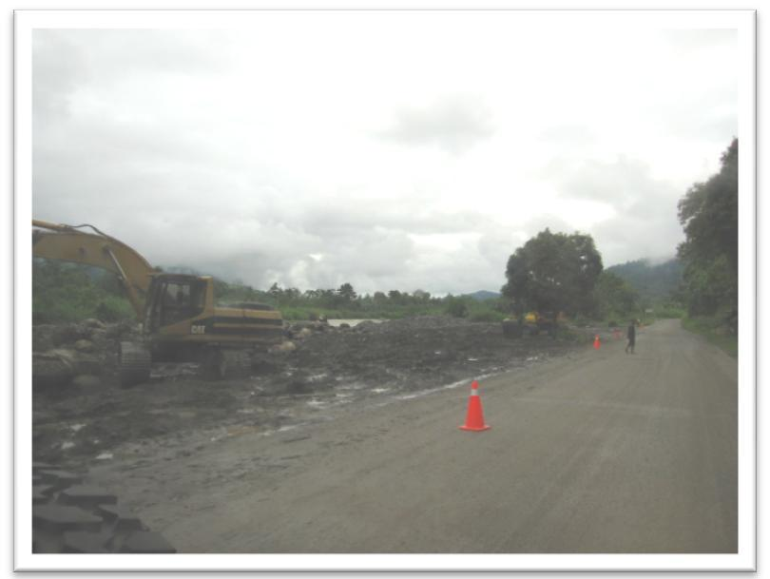

 |  |  |  |  |  | Vision 2050 | 39
 | Objectives | Priority Activity | Key Outcomes | Key Performance |  | Means of
 |  |  |  | Indicators |  | Verification


Reform the public service, legal and political systems to be efficient and effective, and improve the delivery of services to all citizens.



Effective legal system.


Public Private Community Partnership.


 | • Cultivate | • | The public | • Productivity and |  | • | Standard and
 | organisational |  | service at the | performance of the |  |  | cost of service
 | ethics and work |  | national, | public service. |  |  | delivery.
 | culture to |  | provincial and
 | ensure efficient |  | district levels is
 | and effective |  | efficient and
 | delivery of |  | effective in
 | services. |  | delivering
 |  |  | services.
 | • Conduct | • The Legal and |  | • Productivity and |  | • Performance
 | training and |  | judicial systems | performance of the |  |  | appraisals by
 | revamp |  | are efficient. | legal and judicial |  |  | clients.
 | management |  |  | systems.
 | systems to
 | ensure a high
 | level of
 | professionalism
 | .
 | • Establish | • | The political | • Productivity and |  | • | Annual reports
 | partnership |  | system | performance of the |  |  | highlighting
 | with other |  | promotes | political system. |  |  | productivity and
 | development |  | stability, |  |  |  | performance.
 | stakeholders. |  | gender |  |  | • | Number of
 |  |  | equality, |  |  |  | accomplished
 |  |  | democracy, |  |  |  | projects
 |  |  | transparency, |  |  |  | outsourced
 |  |  | and |  |  |  | under the Public
 |  |  | accountability. |  |  |  | Private
 |  |  |  |  |  |  | Community
 |  |  |  |  |  |  | Partnership.

Table 3.3: Strategies for Strategic Focus Area Three: Institutional Development and Service Delivery

- Security and International Relations: Security and law and order remain major concerns that impede national development. The security of our sovereign territory and boundaries remains vulnerable to perceived and unperceived threats. Vision 2050 will ensure that all security agencies, and strategic plans and goals must be adequately supported and funded in order to maintain law and order, including national security and consciousness.

14.1 The Royal Papua New Guinea Constabulary’s manpower level is a critical factor for ensuring safe and secure communities. As the population grows, the RPNGC must also increase its manpower to be able to provide adequate security for our people, investors and properties. Correctional Service programs must also be supported to enable rehabilitation of inmates.

14.2 Papua New Guinea’s international borders are open to hostile activities and must be immediately improved and protected. Adequate funding for the security forces is necessary to enable relevant infrastructure development for border surveillances.

14.3 It is imperative that the Customs Office and the National Agriculture Quarantine Inspection Authority are adequately funded to ensure quality assurance of all inbound imports and outbound exports, respectively.

- Vision 2050

14.4 Papua New Guinea’s foreign policy, including its international relations and diplomacy, has been overtaken by time, global events and circumstances. The conduct and management of international relations remains uncoordinated and poorly managed, with no vision, mission and goals. Thus, an immediate foreign policy review is required to accommodate the challenges and opportunities which are presented by globalization and regional developments. A professional cadre of diplomats and an accompanying National Foreign Service structure and funding are critical. This pillar will be responsible for creating an environment that is conducive for robust regional and international trade relations.

 | Objective |  |  |  | Priority Activity |  |  | Key Outcomes |  |  | Key Performance |  |  |  | Means of
 |  |  |  |  |  |  |  |  |  |  | Indicators |  |  |  | Verification
 | Make Papua |  |  |  | • | Promote and |  | • | Citizens are law |  | • | Low crime and |  |  | • National and
 | New Guinea a |  |  |  |  | facilitate dialogue |  |  | abiding, with the |  |  | conflict record. |  |  | international
 | safe and |  |  |  |  | and peaceful |  |  | highest respect for |  |  |  |  |  | reports on crime
 | peaceful |  |  |  |  | resolution to |  |  | human rights. |  |  |  |  |  | and humanity.
 | society in the |  |  |  |  | conflicts.
 | world.
 |  |  |  |  | • | Increase capacity |  | • | People embrace |  | • | Papua New |  |  | • National and
 |  |  |  |  |  | for law and order |  |  | vast cultural |  |  | Guinea is a |  |  | international
 |  |  |  |  |  | enforcers. |  |  | diversity as |  |  | safe, pleasant, |  |  | reports on
 |  |  |  |  |  |  |  |  | blessings, and |  |  | and exciting |  |  | tourism.
 |  |  |  |  |  |  |  |  | institutionalize |  |  | society in
 |  |  |  |  |  |  |  |  | them as symbols |  |  | which to live.
 |  |  |  |  |  |  |  |  | of national identity
 |  |  |  |  |  |  |  |  | and national unity.
 | Develop |  |  |  | • | Increase capacity |  | • | Papua New Guinea |  | • | High business |  |  | • National and
 | robust |  |  |  |  | for law and order |  |  | is a secure society |  |  | and investor |  |  | international
 | regional and |  |  |  |  | enforcers. |  |  | for business and is |  |  | confidence. |  |  | reports on
 | global |  |  |  |  |  |  |  | a very attractive |  |  |  |  |  | tourism.
 | cooperation |  |  |  |  |  |  |  | investment |  |  |  |  |  | • National and
 | and trade |  |  |  |  |  |  |  | destination in the |  |  |  |  |  | international
 | relations. |  |  |  |  |  |  |  | world. |  |  |  |  |  | reports on
 |  |  |  |  |  |  |  |  |  |  |  |  |  |  | business and
 |  |  |  |  |  |  |  |  |  |  |  |  |  |  | security.
 |  |  |  |  | • | Build capacity and |  |  |  |  | • | PNG becomes |  |  | • Increase in the
 |  |  |  |  |  | recruitment for |  |  |  |  |  | a highly |  |  | number of
 |  |  |  |  |  | foreign service. |  |  |  |  |  | preferred |  |  | tourism travels
 |  |  |  |  |  |  |  |  |  |  |  | tourism |  |  | annually
 |  |  |  |  |  |  |  |  |  |  |  | destination.
 |  |  |  |  | • | Devise mechanism |  | • | International |  | • | Postings. |  |  | • Number of
 |  |  |  |  |  | for international |  |  | recognition. |  |  |  |  |  | international
 |  |  |  |  |  | trade. |  |  |  |  |  |  |  |  | posts.

Table 3.4: Strategies for Strategic Focus Area Four: Security and International Relations

Vision 2050 | 41

- Environmental Sustainability and Climate Change:

15.1 Climate change and variability is inevitable and poses one of the greatest challenges to PNG and the world, if scientific prediction of a temperature rise of 2 to 6° degrees Centigrade is reached within 50 to 100 years. It will have a varied and significant impact on the economy, environment and the livelihood of Papua New Guineans, the Pacific Region and the world. There is poor understanding of climate change and variability and hence inadequate adaptation and mitigation measures currently in place in the country. Poor governance, education and awareness must be addressed. There is insufficient attention being given to climate change initiatives by the global communities on issue of adaptation and mitigation that affect developing countries such as Papua New Guinea.

15.2 We owe it to future generations to preserve our uniquely diverse cultures and traditions. Our cultures and traditions identify our uniqueness in the world. Principles and values that are embedded in our time-tested cultures also need to be captured, emulated, and passed on to future generations. Our diverse heritage is our strength, and if tenuously harnessed, is a platform for synergy – where collective wisdom from 800 or more tribes can be a force for greater outcomes. The embracing of Christian values and principles by our forefathers further adds value to our identity and presence. Embracing time-tested principles and values, aligned with Christian teachings, will ensure that our citizens’ conduct is guided through ethical and moral values. Therefore, all institutions are to align their programs and systems to re-engineer a learning process to instil a holistic human capital asset.

15.2.1 Immediate measures must be taken to ensure that Papua New Guinea is sufficiently cushioned from any adverse impact brought on by climate change. Critical measures to prevent the erosion of climate security, including viable food production and personal health, must be assured. Importantly, Papua New Guinea’s natural resources and environment must be conserved and used for the benefit of all.

15.2.2 The issue of sustaining our environment, cultural heritage and resource management will remain major challenges for the future. Urgent measures must be taken to protect PNG’s environment and its future sustainability. PNG must consolidate its participation in international forums pertaining to environmental sustainability and climate change.

15.2.3 Our environment policy promotes a sustainable development strategy through the ‘wise use’ principle. Proper environmental management will ensure that environmental benefit will be enjoyed by the present generation and that there will be investment for future generations. It also emphasises the importance of conserving biodiversity and promoting sustainable use in economic planning. PNG needs to devise appropriate strategies to deal with conservation and carbon trade issues.
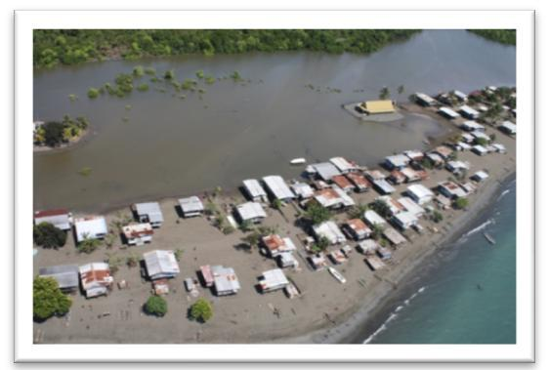
- Vision 2050

 |  | Objective |  |  |  | Priority Activity |  |  |  |  | Key Outcomes |  |  |  |  | Key Performance |  |  |  | Means of
 |  |  |  |  |  |  |  |  |  |  |  |  |  |  |  | Indicators |  |  |  | Verification
 |  | Sustainable development |  |  |  | • | Develop |  |  |  | • | Sound policy and |  |  |  | • Less logging for |  |  |  | • | Legal cases
 |  | measures developed in all sectors |  |  |  |  | appropriate |  |  |  |  | legal framework for |  |  |  |  | exports. |  |  |  | and reports
 |  | to increase resilience to the |  |  |  |  | adaptation and |  |  |  |  | the sustainable |  |  |  | • Communities’ |  |  |  |  | on
 |  | impacts of climate change and |  |  |  |  | mitigating |  |  |  |  | management of |  |  |  |  | resilience is enhanced |  |  | • | environment.
 |  | environmental changes. |  |  |  |  | strategies on |  |  |  |  | natural resources |  |  |  |  | in villages. |  |  | • | Increased
 |  |  |  |  |  |  | climate change |  |  |  |  | and mitigating |  |  |  | • | Sustainable |  |  |  | forest and
 |  |  |  |  |  |  | and |  |  |  |  | climate change and |  |  |  |  | development policies |  |  |  | land-use areas
 |  |  |  |  |  |  | environmental |  |  |  |  | hazards. |  |  |  |  | completed. |  |  |  | designated for
 |  |  |  |  |  |  | changes. |  |  |  |  |  |  |  |  | • Oceans and marine |  |  |  |  | carbon
 |  |  |  |  |  |  |  |  |  |  |  |  |  |  |  |  | and terrestrial areas |  |  | • | opportunities.
 |  |  |  |  |  |  |  |  |  |  |  |  |  |  |  |  | protected. |  |  | • | Large
 |  |  |  |  |  |  |  |  |  |  |  |  |  |  |  | • Forests are protected |  |  |  |  | renewable
 |  |  |  |  |  |  |  |  |  |  |  |  |  |  |  |  | and sustained. |  |  |  | energy
 |  |  |  |  |  |  |  |  |  |  |  |  |  |  |  |  |  |  |  |  | projects
 |  |  |  |  |  |  |  |  |  |  |  |  |  |  |  |  |  |  |  |  | developed
 |  | Conserve and use our natural |  |  |  | • | Develop |  |  |  | • | Sound institutional |  |  | • |  | Professional |  |  | • | National and
 |  | resources and environment for th | e |  |  |  | policies and |  |  |  |  | framework for |  |  |  |  | competence and |  |  |  | international
 |  | collective benefit and for future |  |  |  |  | organizational |  |  |  |  | sustainable |  |  |  |  | world standard |  |  |  | environment
 |  | generations. |  |  |  |  | structures to |  |  |  |  | management of |  |  |  |  | research programs on |  |  |  | management
 |  |  |  |  |  |  | address |  |  |  |  | natural resources |  |  |  |  | environment and |  |  |  | and research.
 |  |  |  |  |  |  | climate change |  |  |  |  | and mitigating |  |  |  |  | climate change.
 |  |  |  |  |  |  | and |  |  |  |  | climate change.
 |  |  |  |  |  |  | sustainability
 |  |  |  |  |  |  | development.
 |  | Improve understanding on |  |  |  | • | Strengthen |  |  | • World class education, |  |  |  |  | • 70 percent of PNG |  |  |  |  | • | Community
 |  | environmental sustainability and |  |  |  |  | research and |  |  |  | research, and |  |  |  |  |  | forests are |  |  |  | and
 |  | climate change with educational |  |  |  |  | develop |  |  |  | sustainable |  |  |  |  |  | conserved and |  |  |  | stakeholder
 |  | awareness on economic |  |  |  |  | infrastructure |  |  |  | management of |  |  |  |  |  | managed for carbon |  |  |  | feedback on
 |  | opportunities, such as carbon |  |  |  |  | , capacity, and |  |  |  | natural resources and |  |  |  |  |  | trade purposes. |  |  |  | services.
 |  | trade and tourism. |  |  |  |  | programs. |  |  |  | mitigating climate |  |  |  | • |  | Oceans and land |  |  | •
 |  |  |  |  |  |  |  |  |  |  | change. |  |  |  |  |  |  |  |  | •
 |  |  |  |  |  |  |  |  |  |  |  |  |  |  |  |  | resources managed. |  |  | • | Policies
 |  |  |  |  |  |  |  |  |  |  |  |  |  |  | • |  | Mitigation measures |  |  |  | implemented.
 |  |  |  |  |  |  |  |  |  |  |  |  |  |  |  |  | for all forms in
 |  |  |  |  |  |  |  |  |  |  |  |  |  |  |  |  | industries, mining,
 |  |  |  |  |  |  |  |  |  |  |  |  |  |  |  |  | energy, and waste.
 |  | Converse and wisely use our |  |  | • |  | Develop policies |  |  |  | • | Sound institutional |  |  |  | • | Professional |  |  | • | National and
 |  | natural resources and |  |  |  |  | and |  |  |  |  | framework for |  |  |  |  | competence and |  |  |  | international
 |  | environment, language and |  |  |  |  | organizational |  |  |  |  | sustainable |  |  |  |  | world standard |  |  |  | environment
 |  | cultural diversity for the |  |  |  |  | structures to |  |  |  |  | management of |  |  |  |  | research programs |  |  |  | and
 |  | collective benefit of the present |  |  |  |  | address climate |  |  |  |  | natural resources |  |  |  |  | on environment and |  |  |  | management
 |  | and future generation. |  |  |  |  | change and |  |  |  |  | and mitigating |  |  |  |  | climate change. |  |  |  | and research.
 |  |  |  |  |  |  | sustainability |  |  |  | • | climate change. |  |  |  | • | Increase tourism |  |  | • | BPNG
 |  |  |  |  | • |  | development. |  |  |  | • | Develop inventory of |  |  |  |  | sector’s contribution |  |  |  | Economic
 |  |  |  |  | • |  | Develop |  |  |  |  | biodiversity, |  |  |  |  | to GDP. |  |  |  | Bulletin
 |  |  |  |  |  |  | enabling policies |  |  |  |  | language and |  |  |  |  |  |  |  |  | Quarterly
 |  |  |  |  |  |  | through legal |  |  |  |  | cultural diversity.. |  |  |  |  |  |  |  |  | Reports.
 |  |  |  |  |  |  | instruments.
 |  | Effective partnership and |  |  | • |  | Identify |  |  |  | • | Participate in, and |  |  |  | • | Adherence to |  |  | • | Reports from
 |  | cooperation with international |  |  |  |  | strategic |  |  |  |  | benefit from, |  |  |  |  | international |  |  |  | respective
 |  | community on environmental |  |  |  |  | partners and |  |  |  |  | international |  |  |  |  | agreements. |  |  |  | departments
 |  | sustainability and climate issue. |  |  |  |  | develop |  |  |  |  | arrangements on |  |  |  |  |  |  |  |  | and
 |  |  |  |  |  |  | programs that |  |  |  |  | environmental |  |  |  |  |  |  |  |  | institutions.
 |  |  |  |  |  |  | strengthen |  |  |  |  | sustainability and
 |  |  |  |  |  |  | partnership |  |  |  |  | climate change.
 |  |  |  |  |  |  | arrangements.


Table 3.5 Strategies for Strategic Focus Area Five: Environmental Sustainability and Climate Change
Vision 2050 | 43

- Spiritual, Cultural and Community Development: Churches have contributed significantly towards the integral human development of our people since their settlement in Papua New Guinea. They have continued to provide health and education services as part of their ministry and gospel work. Although the churches have taken on more than 40 percent of the basic health and education services, there has been scant financial support from the Government. During the nationwide consultations, Papua New Guineans called on the Government to support the churches. Many claimed that the churches are with the people and can reach the remotest parts of the country, where the Government is not able to.

16.1 Mind pollution, resulting from exposure to unethical communication mediums, remains a threat to gender discrimination and the maintenance of a respectful society. The current generation seems to have lost respect for our culture and traditions.

16.2 The role of the churches, as partners in national development, must be welcomed and encouraged. The churches are expected to be united in fostering partnerships for national development. It is expected that they will work in conjunction with the State, as well as independently.

 | Objective |  | Priority Activity |  |  | Key Outcomes |  |  |  | Key Performance |  | Means of Verification
 |  |  |  |  |  |  |  |  |  | Indicators
 | Instil positive |  | • Introduce religious |  |  | • People have a |  |  |  | • Churches to play a |  | • Local and national
 | attitudes and values |  |  | instruction at all levels of |  |  | positive attitude and |  |  | more active role in |  |  | reports on good
 | of respect, integrity, |  |  | education and fellowship in |  |  | outlook on life. |  |  | people |  |  | governance.
 | excellence, and |  |  | all government offices and |  |  |  |  |  | transformation and
 | discipline in people. |  |  | SOEs. |  |  |  |  |  | empowerment.
 | Involve the churches |  | • Develop a policy |  |  | • Improvement in |  |  |  | • Churches and civil |  | • Reduction in corruption
 | and NGOs as equal |  |  | framework to enable |  |  | Government through |  |  | society to play a |  |  | indicators.
 | partners in |  |  | partnership with church |  |  | good governance, |  |  | more effective role in
 | development and |  |  | and NGO-based |  |  | transparency, and |  |  | ensuring government
 | service delivery. |  |  | organisations. |  |  | accountability. |  |  | accountability.
 | Develop love for God, |  | • Develop a love for PNG, |  |  | • | The nation that |  |  | • People will love God, |  | • Respect for God, others,
 | citizens, foreigners, |  |  | her leaders, people, |  |  | kneels in prayer will |  |  | their citizens, their |  |  | and themselves, their
 | work, creation, and |  |  | hopes, and dreams, |  |  | stand on a solid rock |  |  | foreigners, their |  |  | environment, and
 | property. |  |  | through prayer every day. |  |  | despite all kinds of |  |  | work, creation, and |  |  | property they use.
 |  |  |  |  |  |  | circumstances. |  |  | property will
 |  |  |  |  |  |  |  |  |  | increase.
 | Improve and increase |  | • Develop a policy for |  |  | • | Churches increase |  |  | • More leaders will |  | • Many leaders will retire
 | chaplaincy services to |  |  | partnership in engaging |  |  | involvement in |  |  | manage life |  |  | and live smart, wise, fair,
 | Parliament, all |  |  | chaplains for Parliament |  |  | serving, and |  |  | pressures of |  |  | healthy, and happy lives.
 | security forces, and |  |  | and key government |  |  | reducing pressures |  |  | leadership and
 | all government |  |  | institutions. |  |  | in the lives of |  |  | broken family
 | institutions. |  |  |  |  |  | leaders. |  |  | relationship.
 | NGOs and churches |  | • | Develop systems and |  | • | More people have |  | • Churches to play a |  |  | • | Local and national
 | as equal partners in |  |  | protocols for engagement |  |  | easier and increased |  |  | more active role in |  |  | reports on the social
 | development and |  |  | with church-based |  |  | access to basic |  |  | the delivery of basic |  |  | indicators.
 | service delivery. |  | • | organisations. |  |  | services. |  |  | services to the |  | • | Community and
 |  |  | • | Provide management |  |  |  |  |  | people. |  |  | stakeholder feedback on
 |  |  |  | training for church-based |  |  |  |  |  |  |  |  | services.
 |  |  |  | organisations.

Table 3.6: Strategies for Strategic Focus Area Six: Spiritual, Cultural, and Community Development

- Strategic Planning, Integration and Control: The successful implementation of Vision 2050 requires the establishment of an independent entity to provide monitoring and evaluation of its progress.
- Vision 2050

17.1 Vision 2050 provides the pathways forward to achieve progressive and systematic long-term planning and management of resources for real and sustainable nation building. This pillar will ensure that Papua New Guinea has sound, clear, achievable and progressive long-term policies and programs. The pillar carries out strategic reviews of major policy areas, works with central agencies and line agencies to promote strategic thinking, conducts regular strategic audits and monitors and evaluates the long-term Vision 2050.

The development of an information and communication strategy to drive Vision 2050 is necessary.

17.2 Planning in PNG is hampered through lack of credible and consistent data. The National Statistical Office (NSO), Census Office, National Mapping Bureau, National Weather Service and Birth Registry Division of the Department for Community Development have to be adequately funded to provide up-to-date information for planning purposes.

17.3 Vision 2050 will ensure that all bilateral and multilateral arrangement, as well as foreign and trade policies, are continuously aligned to Vision 2050. These will ensure consistency to the nation’s development agenda.

17.4 Surplus and unspent government funds that are ‘parked in trust accounts’ must be returned to consolidated revenue in order to be reappropriated and managed in an open and transparent manner.

 | Objective |  | Priority Activity |  |  | Key Outcomes |  | Key Performance |  |  | Means of
 |  |  |  |  |  |  |  | Indicators |  |  | Verification
 | Sound strategic |  | • Develop a |  |  | • Papua New Guinea |  | • Development plans |  |  | • | Corporate,
 | direction for |  |  | sound Vision |  | has a sound, clear, |  |  | and policies are |  |  | strategic, and
 | development and |  |  | 2050. |  | and practical |  |  | aligned with greater |  |  | business plans of
 | nation building. |  |  |  |  | strategic direction |  |  | coordination and |  |  | key stakeholders.
 |  |  |  |  |  | for long-term |  |  | control.
 |  |  |  |  |  | development.
 | Operational cascade |  | • | Align |  | • Outcomes of the |  | • | Greater |  | • | Annual reports
 | vision and mission |  |  | medium-term |  | medium-term |  |  | involvement and |  |  | highlighting
 | statement. |  |  | development |  | development |  |  | collaboration |  |  | financial and
 |  |  |  | strategies to |  | strategies are |  |  | among key |  |  | management
 |  |  |  | Vision 2050. |  | logical, progressive, |  |  | stakeholders. |  |  | performances.
 |  |  |  |  |  | and aligned to Vision
 |  |  |  |  |  | 2050.
 | Monitor and |  | • | Align policy and |  | • National, provincial |  | • | Corporate and |  | • | Annual program
 | evaluate |  |  | budget to |  | and district policies, |  |  | sectoral plans are |  |  | reports and
 | implementation of |  |  | Vision 2050. |  | plans, and budgets |  |  | aligned to Vision |  |  | independent
 | Vision 2050. |  |  |  |  | are aligned to Vision |  |  | 2050’s goals and |  |  | feedback from
 |  |  |  |  |  | 2050. |  |  | objectives. |  |  | clients.
Table 3.7: |  | Strategies for Strategic Focus Area Seven: Strategic Planning, Integration, and Control

Vision 2050 | 45

18. Successful Implementation of Vision 2050

The successful implementation of Vision 2050 lies in:

18.1 Central and line agencies of government supporting and proactively facilitating the development framework of Vision 2050;
- 2Human resources are made available;
18.3 Political stability ensuring consistency in government policies;

18.4 Minimal or no changes to current macroeconomic forecasts over the next 20 to 30 years;
18.5 Marked improvement in governance and the performance of the political system.

18.6 Marked reduction in corruption, mismanagement and misuse of public assets and resources;

18.7 All government systems and institutions being fully reformed and aligned to Vision 2050;

18.8 All key stakeholders actively supporting and aligning their development agendas to Vision 2050;

18.9 The Government at all levels adequately resourcing and funding the Vision 2050 programs; and

18.10 An appropriate institutional and operational framework established to drive Vision 2050, including planning and determination of Vision 2050 core programs.

19. Key Milestones of Vision 2050

The key milestones of vision 2050 will be achieved when:

19.1 All national, provincial and statutory institutions and district policies, plans, and budgets are immediately aligned to Vision 2050;

19.2 The public service at the national, provincial and district levels are functioning efficiently and effectively;

19.3 Legal and judicial systems in PNG are operating efficiently;

19.4 The political system in PNG is actively promoting stability, gender equality, democracy, transparency, accountability and economic development in Papua New Guinea’s national interest;

19.5 Medium-term and Long-term development plans for the Southern, Momase, New Guinea Islands and Highlands Regions are aligned to Vision 2050;

19.6 Southern, Momase, New Guinea Islands and Highlands Regions each have completed implementation-ready documentation for one major impact project in each of the following areas — agriculture, forestry and fisheries and tourism ;

19.7 Funding is secured for each of the major impact projects in agriculture, forestry, fisheries, and tourism for the Southern, Momase, New Guinea Islands and Highlands Regions;

19.8 PNG has sound trade and export sectoral strategies, has developed new markets and has improved its rate of compliance with international rules and standards;

19.9 Churches are engaged more actively in the growth, development and empowerment of Papua New Guineans;

19.10 Churches and civil society are jointly playing an active and effective role in advocating and promoting accountability in government;

19.11 Churches in PNG are playing a more effective and increased role in the delivery of basic services to the people;
- Vision 2050

19.12 State-owned enterprises (SOEs) are effective and efficient in service delivery;

19.13 Major impact projects have been nominated and implemented under Public –Private Partnership arrangements;

19.14 The National Development Bank is reformed and the primary industry sector (agriculture, forestry, fisheries and tourism) lending is increased by 200 percent;

19.15 Sustainable development policies are developed and implemented to increase the resilience of 80 percent of people in vulnerable provinces, especially the highlands, islands and coastal areas;

19.16 Information communication technology and early warning systems are installed in each province to support economic livelihoods and the environment, especially the education and health sectors;

19.17 Communities benefit from climate change and environmental sustainability initiatives and opportunities under the carbon trade, in relation to land and ocean resources;

19.18 By 2020, Papua New Guinea’s sporting and recreation infrastructure and management are to be improved to world class standards;

19.19 By 2015, food imports, including meat and vegetables are reduced by 25 percent;

19.20 By 2020, PNG is a preferred country in which to do business and its policies will be conducive to trade and investment development;

19.21 By 2020, the education system in PNG is of world class standard, relevant and progressive;
19.22 By 2020, Universal Basic Education is achieved; and

19.23 By 2020, the education system will progressively enhance gender parity and equality in accessing formal education and needs-based training.

- Core Strategic Development Areas: From the nationwide discussions and feedback received from those district consultations, Vision 2050 now settles on three core program areas which will be at the heart of the whole Plan. These areas are Institutional Development and Service Delivery, Wealth Creation, and Human Capital Development. All other Strategic Focus Areas will provide critical support to these three core development areas. Under service delivery, the focus is on developing better platforms to ensure that services are directly delivered to the people. Wealth creation will ensure that 70 percent of the country’s income is derived from renewable resources and the development of entrepreneurial skills. Human capital development is expected to produce a knowledgeable, empowered, committed, and productive work force and population.

20.1 Service Delivery and Institutional Development: During the Vision 2050 district consultations, it was noted with great concern that districts lack the capacity to deliver government services. In many government outposts, public servants are absent and are residing elsewhere. Apart from a lack of infrastructure, government funds that are intended for development and service delivery rarely translate into anything tangible. It was noted that the current arrangements between the national and provincial governments are not conducive to development and service delivery in districts and local-level government areas.

20.2 Infrastructure Development: The country’s infrastructure, such as roads, airstrips, buildings, bridges, sporting amenities, communication, electricity, water supplies and sanitation have continued to provide the foundation for development. However, major constraints are faced by the country in this sector. The government’s approach to infrastructure development and maintenance needs immediate attention. Urgent rehabilitation, prioritisation and sustained support to maintenance programs will ensure that state Infrastructure assets are in good condition and that their usable life is extended. The infrastructure platform is the main catalyst upon which service delivery programs and programs for sustaining people’s livelihoods rely.

Infrastructure development is vital and must be given priority in all of the government’s development agendas.

Vision 2050 | 47

20.3 Provincial and Local-Level Service Monitoring Authority (PLLSMA): The PLLSMA has been established to coordinate and monitor national policies at the provincial and local government levels, with the ultimate goal of improving service delivery. The coordinating role is undertaken by a subcommittee comprising all key sectors, such as agriculture, works, transport, communication, health, law and justice, and the National Economic and Fiscal Commission. The provincial subcommittee provides plans for coordination, implementation, monitoring, and reporting. The PLLSMA should collaborate with line agencies, and Provincial, District and Local-level Governments in the planning and implementation of priority programs, such as the District Services Improvement Program (DSIP), the National Agriculture Development Plan (NADP), the Rural Education Services Improvement (RESI), the Constitutional Grants (discretionary and non-discretionary), the Health Sector Improvement Program (HSIP), the District Transport Improvement Program (DTIP) and others.

20.4 State Owned Enterprises (SOEs): The prime mandate of governments all over the world is to service the needs of its citizens. Infrastructure such as roads, electricity, telecommunication, wharves, jetties, airstrips and airports are necessary prerequisites for economic growth. Furthermore, social and community services, including health, education, recreational and welfare programs are essential for survival in modern societies. Experiences have shown that there is a close relationship between infrastructure and economic output in both advanced and developing countries.

20.4.1 Despite PNG’s relative strong economic performance in recent years, its infrastructure and social services have virtually deteriorated beyond repair. There is an urgent need to increase investment in SOE reforms, including in the areas of maintenance and capital expenditure. The implementation of the Public Private Partnerships (PPPs) and community services obligation policy in the medium-term and long-term will enable private sector participation and contribution to infrastructure development and other service delivery initiatives.

20.5 Public Private Community Partnership (PPCP) Policy: Consistent with the past and current governments’ objective to maximise partnership with the private sector, a PPCP policy was endorsed by the Government in December 2008. Under the new PPCP policy framework, the private sector will have a wider role in financing and managing future large infrastructure investments as well as other projects in the social and wealth creation sectors. Potential impact projects will be nominated as part of the National PPCP Infrastructure Plan for implementation during the planning period. The proposed PPCP centre will need to be aligned to the Vision 2050 implementation framework to bring about effective coordination and resourcing. The approval and implementation of the community services obligation policy will also help to facilitate the increased involvement of the private sector in service delivery and the expansion of services. The major projects that were identified through the economic corridor planning exercises will be facilitated through the PPP framework.

20.6 Development Partners: Donor organizations provide valuable development assistance. There has been a significant flow of donor-sponsored assistance and resources to PNG over the past 34 years. However, not all donor support has been effective. The Papua New Guinea Vision 2050 framework provides a good opportunity for better and more effective dialogue, commitment, engagement, realignment, and review of the donors' performance in the planning and implementation of priority impact projects. Vision 2050’s proposal will enable future governments to better identify and clearly articulate to donors the priority projects and programs that need funding support or assistance.
- Vision 2050

20.7 Churches and Non-Government Organizations (NGOs): Many NGOs are involved in development programs. Principal among them are the churches which have a long history of providing effective services in health, education and social welfare, especially in the more remote parts of the country. The churches played a key role in the provision of health and education services prior to independence and continue to contribute substantially to service delivery using their extensive networks. NGOs collectively spend large sums of money to achieve their organizational objectives. International NGOs have extensive networks through which both technical and financial support is sourced from their in-country programs. Local NGOs, which are mostly based in the rural areas, deliver services over a long period of time, with limited funding. A broader NGO-Government policy framework must be developed under the auspices of Vision 2050, for community development and service delivery. The recently executed Church-Government Partnership would be facilitated under the broad NGO policy framework.

20.8 Service Delivery Mechanism Model (SDMM): The development of an appropriate Service Delivery Mechanism Model (SDMM) for bottom-up planning and improved service delivery at the ward and district levels was approved for implementation by the Public Services Reform Management Unit (PSRMU), in consultation with the Provincial and Local-Level Service Monitoring Authority (PLLSMA). The project provides an opportunity for baseline data collection and analysis and the design of the SDMM that would enable direct funding, planning, monitoring, reporting and improvement of services at the district and ward levels.

20.9 Political Options for Better Service Delivery: The Organic Law on Provincial Governments and Local-level Governments (OLPGLLG) has failed to achieve its primary role of effective service delivery to the people. This has led to calls by politicians and their constituents for the Organic Law to be repealed and a much simpler form of decentralization introduced. In order to facilitate effective planning and implementation of Vision 2050 and the achievement of its objectives, in the long term, it will require an effective functioning political and administrative system. The Taskforce on Government and Administrative Reforms recommended three political options:

- a two-tier government (national and local-level);
- a three-tier system of government (national, provincial and local); and
- a bicameral house (senate).

20.9.1 The issues relating to women’s representation have also been considered in the political reform agenda. The Leaders’ Summit that was held in August 2009, in Lae, endorsed the three-tier government, but suggested that it needs modification. The recommendation for the provision of reserved seats for women was also endorsed. Adequate resources need to be provided for priority implementation, commencing in 2010.

20.10 Wealth Creation: Not enough has been done to support and empower Papua New Guineans to create wealth from the country’s vast renewable and non-renewable natural resources. There has been very little emphasis given to building the entrepreneurial skills of our people to grow the small-to-medium enterprise (SME) sectors and to the effective use of natural resource rent to sustain income flows in the future. Furthermore, the nation’s economic wealth continues to be unfairly and inequitably distributed. Papua New Guinea’s economy continues to be dominated by the mining and energy sectors.

Vision 2050 | 49

20.10.1 It is the intent of Vision 2050 that the renewable resource sector, including manufacturing, will contribute around 70 percent to the country’s GDP. In the future, under Vision 2050, agriculture is expected to contribute 30 percent to GDP, tourism 20 percent, and forestry and fisheries a further 20 percent. The strategic direction of Vision 2050 will provide the framework in alignment with respective sectors to develop these revenue-based sectors from 2010 to 2050. Six key indicators will be used to track the progress of efforts in order to empower citizens to maximise the wealth from the vast renewable natural resources and ensure that the nation’s wealth is distributed fairly and equally to all Papua New Guineans.

20.10.2 These key indicators are:

20.10.2.1 Optimal utilisation of Papua New Guinea’s customary land for economic activities, without compromising social and cultural customary tenure;
20.10.2.2 Marked increase in export revenue;
20.10.2.3 Increased transition and adjustment by relevant industries to
downstream processing and value adding activities;

20.10.2.4 Marked increase in the number of small businesses becoming medium-sized enterprises;

20.10.2.5 Marked increase in the number of indigenous Papua New Guineans participating in economic activities; and

20.10.2.6 Marked increase in the productivity levels in all sectors of Papua New Guinea’s economy.

20.11 Land Utilization: Land is an important factor of production. It has great potential to contribute to medium-term and long-term development objectives in wealth creation and economic growth. Although Papua New Guinea has a land area of some 461 690 km², it has been generally difficult to access it, either under customary tenure (97 percent), or alienated land which is administered by the Government (three percent). The challenge is in finding ways to utilise land under traditional ownership in a way that does not compromise traditional land security, while at the same time making it conducive for economic growth and diversity. However, it is widely acknowledged that administration of the state’s three percent is poor.

20.11.1 The inherent problems of land administration, lack of awareness of landowners regarding legal provisions, procedures for registration and use of customary land for socioeconomic development are constraints to growth. Vision 2050 is committed to providing guidelines and scenarios for land administration in collaboration with the Department of Lands and Physical Planning in order to implement land reform programs and explore ways of making landholding more conducive to promoting economic development.
- Vision 2050

20.12 Oceans and Coastal Environments

Papua New Guinea has a total seas and ocean area of 3.12 million square kilometres and a total coast line of 17 110 kilometres which encompasses the coastal peripheries of the mainland and the islands of fifteen of its provinces. The PNG Maritime Boundaries Delimitation project which will define Papua New Guinea’s Exclusive Economic Zone (EEZ) will be concluded in 2010. While the country’s focus has been on land utilisation, the ocean environment has not been developed, mainly because of the poor understanding of ecosystems and the new challenges that are offered.

While fisheries, marine biodiversity, transportation infrastructure, and some mining activities continue to do well in the country, greater challenges, such as impacts of climate change, natural hazards and security threats, will potentially erode the livelihoods and sustainable impact projects of the country. The implementation of information communication technology (ICT) infrastructure would contribute significantly to developing vital facilities for the coastal communities. The oceans and waters ecosystems of the country possess a great abundance of marine and mining opportunities for sustainable development. Vision 2050 should now focus in this area with the potential economy and environmental impact activities. A no regret ocean policy is urgently required and must be developed to enhance our prosperity before 2011.

20.13 Agriculture: The agriculture sector is extremely important as it provides for the needs of the majority of our people and is likely to do so for the foreseeable future. However, since independence, the agriculture sector’s contribution to GDP has declined. At present, the non-renewable resources sector (gold, copper and oil) accounts for approximately 77 (80%) percent of the total value of exports, while the primary industry sector accounts for only 23 percent — agriculture (17%), forestry (5%), and fisheries (1%). The poor and declining performance of the agriculture sector is of great concern. Eighty-five percent of Papua New Guineans who live in the rural areas depend on agricultural produce to sustain their basic livelihood and the sale of cash crops as an important source of income. While PNG has great agricultural potential to grow and meet its domestic requirements, it still imports a large volume of agricultural products, including vegetables, proteins and grains, resulting in the expenditure of substantial export earnings. The National Agricultural Development Plan will be implemented under the auspicious of Vision 2050, over the medium to long term period, to provide better and innovative agricultural practices. Vision 2050 encourages major impact projects in the agricultural sector which are associated with downstream processing and import replacement.

20.14 Forestry: Most forests in PNG are owned by customary landowners. The dominant activity in the predominantly foreign-owned forestry sector is industrial logging, which makes a significant contribution to export revenue predominantly. There is very little investment associated with value adding and downstream processing in industrial logging. Furthermore, there is very little investment in research and development of plantation forestry. Papua New Guinea’s forests play a significant role in the ecosystems and environmental functions that are beneficial to sustaining bio-functions. They also contribute to the local and global economies. Vision 2050 will work with forestry sector stakeholders, including the National Forest Authority, the logging industry, the international community, and the conservation sector in devising appropriate policies for the sustainable management of Papua New Guinea’s forest resources. This includes developing a policy framework for climate change mitigation and carbon trade.

Vision 2050 | 51

20.15 Fisheries: The fisheries sector in PNG comprises subsistence and commercial fishing. This sector is the largest renewable resource sector contributor to Papua New Guinea’s export earnings, after agriculture and forestry. Papua New Guinea has embarked on substantial downstream processing in the fisheries sector to increase revenue. PNG currently has four tuna processing facilities, in Madang, Wewak, and Lae. Madang is also developing a marine park which is aimed at attracting more downstream facilities to the country. PNG has a huge potential for more downstream processing in the fisheries sector. For example, in the purse seine category alone, only 34 out of 186 licensed boats have their catches processed in PNG. Of these vessels, only seven are owned by national companies. Vision 2050 will work with the fisheries sector agencies in the development of sustainable management strategies for fisheries and marine resources. The key strategic areas include:

- research, development and information dissemination;
- easy access to credit services;

- surveillance and monitoring;
- improved market access for fisheries and marine products;

- building institutional capacity at provincial, district and local government to improve coastal fisheries management; and

- develop aquaculture as a priority program targeting inland areas for wealth creation.

20.16 Tourism: Papua New Guinea is richly blessed with abundant terrestrial and marine natural resources. Combined with beautiful and pristine natural environments, impressive ranges of mountains and spectacular coral reefs, these resources give the country an international reputation for experiencing scuba diving, volcanoes and rugged mountain ranges, beautiful beaches and tropical rainforest which contains lush vegetation and myriad animal species. The rainforest is home to an impressive variety of exotic birds. We also have over 800 languages, resulting in our very large cultural diversity which has immense value as a tourism draw card. This positions PNG as a unique tourist destination in the world. Vision 2050’s plans should capture this opportunity and work in collaboration with the PNG Tourist Promotion Authority and other relevant sectors to promote the tourism industry and the necessary infrastructure.

20.17 Entrepreneurship: Lack of education and skills development have contributed to a lax attitude and dependency mentality among the population. This has resulted in our people being unable to enter into small business opportunities which are currently dominated by foreigners. This compounds the rate of growth towards self-reliance. The future development focus under Vision 2050 will shift from a poverty reduction mentality to a positive wealth creation mind-set. It is the intention of Vision 2050 to turn struggling rural Papua New Guinean communities into economic growth centres through the mobilization of the masses. It is essential that a rigorous program in entrepreneurial skills development is established, and that communities are arranged into cooperative societies or nucleus estates for collective economic growth.

20.18 Human Capital Development: Skills development and lack of employment opportunities have been setbacks to human resource development. An affordable and quality education can assist in knowledge and skills development and augment our productive human resource.
- Vision 2050

20.19 Education: The Department of Education is moving towards achieving Universal Basic Education (UBE) and anticipates an 80 percent achievement rate by 2015. However, the retention of students will remain a problem. To intensify human resource development, Universal Basic Education is the launching pad. Corresponding investments are to be made under Vision 2050 to rigorously enhance this process. The current enrolment statistics show that the majority of children are enrolled in primary schools. This signals the need for immediate increase in investment in the secondary, vocational and technical school systems to cater for the increasing student numbers and provide quality knowledge and skills education.

A major expansion of infrastructure, management capacity and strengthening of linkages between primary, secondary, vocational, technical, secretarial and teacher colleges must be carried out. Other critical areas to be addressed include the recruitment of teachers from overseas to fill general teacher and subject specialist shortfalls, improvement of teachers’ qualifications, terms and conditions and their attraction and retention within the teaching service. According to Vision 2050 focus area, vocational schools are to be aligned to the skills and entrepreneurial needs of the community. Training in agriculture, technical trades, and personal viability will be conducted according to the demands of the labour markets.

20.20 Universities and Colleges: Colleges, universities and other higher education and training institutions enrol more than 15 000 students every year. There is a huge gap in terms of the number of students leaving school and those accepted into higher and further education. For example, out of approximately 75 000 students who leave school each year, only 15 to 20 percent are able to find places in higher education institutions (2008). The rest become drop-outs or ‘push-outs’ who are left ill-prepared and disillusioned. High quality human resources can be developed by various training institutions. At the universities, skilled and knowledgeable human resources are produced to meet the knowledge and technological needs and demands of the public and the private sectors. It is estimated that some 320 000 people who have been educated and skilled to international standards will be required by 2030. This requires approximately 16 000 graduates to be produced annually. Under the current educational regime, this requires a significant expansion of both secondary and tertiary educational institutions. The functions of the universities and other institutions of higher learning are to implement policies and strategic directions that have been developed by the Office of Higher Education and aligned to Vision 2050.

20.21 Research and Development: It is essential to ensure that research is carried out to identify, adopt, adapt, and provide solutions to problems and seek innovative pathways to improve social, technical, scientific and economic conditions affecting the people. Research is critical for advancement in modern society. In many developing countries, including PNG, research and development does not feature prominently, because it requires heavy capital investment and involves long periods before there are any tangible outcomes. Papua New Guinea must determine its comparative advantage and find a niche to capitalize on areas of its natural endowment and heritage by developing research programs. Research and higher education institutions, together with industry must collaborate in research and development in order to add value to local knowledge and enterprise. Research must expand to include studies of natural resources, the processing and the downstream treatment of agricultural and natural resource products, new areas such as medicinal biota research and a range of relevant applied research that may yield attractive returns to PNG.

Vision 2050 | 53

20.21.1 New research bodies should be established and or amalgamated with existing institutions, each specializing in different disciplines such as natural sciences (agriculture, forestry, fisheries and general biological sciences). An applied and technological research institute to deal with manufacturing, product development and quality assurance could be part of the current National Institute of Standards and Industrial Technology and be linked to the appropriate technology department at the Papua New Guinea University of Technology. These research institutes would adopt, adapt and generate new production technology for all industries.

20.21.2 If these research institutions are established, then a governing body needs to be formed to oversee their operations. This entity could be called the Research and Development Council of PNG and comprise of prominent citizens with scientific and technical dispositions and representatives of the Government and respective industries.

- Crosscutting Issues: Long-term development plans need to take into consideration crucial cross-cutting issues that may have an adverse impact on the development processes. Vision 2050 is mindful of these consequences. It endeavours to incorporate them into the overall development strategies, as well as alerting responsible sectors to devise measures and remedies to deal with the issues in a positive manner.

21.1 Gender: The National Goals and Directive Principles (NGDP #2), the United Nation’s Millennium Development Goals (MDG #3), and PNG’s Medium Term Development

Strategies, 2005-2010 identify gender as a critical focus area to be proactively addressed at all levels of government, administration, business, and communities, including civil society organizations. There is a huge imbalance and inequity in our society, mostly in favour of the male gender, which marginalises the equitable participation of females in all walks of life. In addition, there are strong cultural beliefs and value systems that require major education and empowerment interventions to imbue young people with a more liberal approach, in order to sensitise them.

21.1.1 Vision 2050 recognises the significance of NGDP #2 and MDG #3, that PNG as a nation has utilised less than 50 percent of the intellectual and creative potential of its people. Vision 2050 envisages — and strongly recommends

— that intervention programs to achieve gender equity must be given more attention and be supported with sufficient resources.

21.2 HIV/AIDS: HIV/AIDS has the potential to undermine the economic and social advancement of PNG. One potential impact of HIV/AIDS is apparent in the overall population growth. Over the Vision 2050 period, the rate of population growth with HIV/AIDS is anticipated to be approximately 16 percent lower than it would have been in the absence of the epidemic. Current statistics on HIV/AIDS must be a concern to the country. It is estimated that 1.28 percent of the population is living with HIV/AIDS (2007).

21.2.1 PNG is already experiencing declining health indicators and HIV/AIDS has the potential to significantly worsen those indicators and affect economic growth. The HIV epidemic in PNG requires innovative approaches, if it is to avoid the patterns of the epidemic in similar underdeveloped countries such as those in Sub-Saharan Africa. Vision 2050 will
- Vision 2050

work in partnership with the National Aids Council Secretariat (NACS) to come up with significant preventive strategies.

21.3 Law and Order: The law and order problem poses a great challenge to the development and implementation of the long-term plan. Low literacy rates, unemployment and social displacements have fuelled law and order problems. In an attempt to escape impoverished rural areas, people are migrating to urban centres where unemployment rates are very high and living conditions unbearable. This situation has created an immense challenge for law and order agencies. Furthermore, the cultivation, marketing and abuse of drugs are on the increase among young people. Papua New Guinea’s law and order situation requires immediate action so that all other potential socioeconomic gains are not jeopardised. Improving the law and order situation is essential to laying the foundations for socioeconomic growth and establishing investor confidence. Adequate budgetary allocations to the Royal Papua New Guinea Constabulary (RPNGC) and to the broader law and justice sector is necessary to combat law and order problems.

21.4 People with Disabilities: Based on international research which was conducted in a number of developed and developing countries, it is estimated that up to 10 to 15 percent of the national population will have some kind of disability. In recent times, people with disabilities have been totally invisible in all areas of the development process. They are among the most vulnerable and marginalised members. People with disabilities should be empowered, their rights recognised and they should be included in the mainstream of social and economic life. Vision 2050 should devise processes whereby a compassionate and family-based society is created which recognises people with disabilities as having the same rights as other citizens. Furthermore, Vision 2050 recognises that, if progress is to be made in addressing the rights and needs of people with disabilities, a strong partnership must be built with civil society including the churches, community-based organisations, development partners and in particular, disability organisations.

- Summary

The National Strategic Plan Taskforce’s extensive district consultations has verified that Papua New Guineans aspire to a vision of having a ‘Smart, Wise, Fair, Healthy and Happy Society by 2050’. This vision will be best achieved if the Medium Term Development Strategy (MTDS), sectoral strategies and corporate plans of sectors and agencies align their strategic objectives to the Vision 2050 and its mission in a cascading manner. Implementation of the Vision 2050 Mission Statement, will be through the seven Strategic Focus Areas.
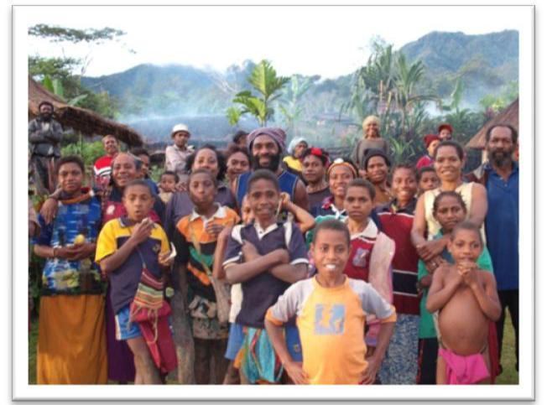

The Future | 55

CHAPTER FOUR: INSTITUTIONAL FRAMEWORK FOR VISION 2050

- Introduction

Vision 2050 is the National Government’s Strategic Directional Statement that will guide the nation’s development agenda over the next 40 years. Given the broad and long-term nature of the vision, it will require an appropriate policy and institutional framework to ensure that effective planning and implementation occurs. The Government must develop appropriate policy and legislative frameworks for institutionalising Vision 2050. This includes amendments to relevant sections of the Constitution and the introduction of appropriate legislation to give effect to the establishment of an independent entity that will drive Vision 2050.

1.1. To achieve objectives in the first few years and ensure medium and longer term benefits, Vision 2050 is dependent on new approaches to systems, processes and mechanisms to ensure that there is a more robust national commitment and that effective internal partnerships are developed.

- National Ownership and Commitment

2.1 Securing unreserved cooperation and commitment of all citizens is essential in implementing the national development objectives.

2.2 Strengthened national capacity for effective participation and cooperation will also be achieved through national planning and budgeting processes to ensure an adequate resource allocation for the financing of all levels of government.

2.3 It is essential to arrange pooling of technical and policy experts from agencies in the country in order to develop human capacity to tackle short-term issues of strategy implementation.

- Partnership

3.1 Closer association between PNG and our bilateral and multilateral development partners will expand our membership of regional agreements and associations, which will lead to a broadening and deepening of national and international cooperation.

3.2 Stronger partnerships at the international and national levels, with non-state actors (NSAs), is also essential. ³¹ This will require a regional accreditation policy and framework for engagement with NSAs, which will encourage the national government to institutionalise a framework for engagement with national civil society organisations.

3.3 As current resources for national cooperation are sourced mainly from development partners and multilateral organisations, stronger engagement will be needed to implement Vision 2050, to effect a better alignment of their programs and reporting requirements with national priorities and processes. Vision 2050 may ultimately form the regional partnership framework for development.

- These include non-government organizations, community-based organizations, faith-based organizations, and private sector associations.
- Vision 2050

- Operational Strategy

4.1 A detailed implementation plan, with realistic objectives and outputs and clearly defined coordination responsibilities will ensure that the goals and priorities of Vision 2050 are achieved. A monitoring and evaluation strategy will measure the progress of the implementation plan and provide information for appropriate modifications when necessary. Vision 2050 Development Indicators will be prepared to enable the evaluation of its progress and compatibility with nationally and globally agreed goals.

- Information and Communication Strategy

5.1 An Information and Communications Strategy for Vision 2050 will promote widespread understanding and support for the implementation plan, targeting national commitment and action, as well as understanding and support from regional organisations, NSAs, development partners and multilateral agencies. National reports, data and inventory can be compiled for ease of reference and advice to the Government — especially leaders. The Information and Communications Strategy will also provide a mechanism for ongoing debate concerning the progress and achievements of Vision 2050 and its future.

- Monitoring Evaluation and Review

6.1 The independent entity will develop a monitoring and evaluation (M&E) framework that will be used to track progress made. All staff will receive training on M&E. Information generated through the reviews will be analysed regularly and documented in quarterly and annual monitoring reports.

6.2 Reviews must be under taken by intervals during the envisioned period. It is important that major reviews are undertaken in 2019, 2029 and 2039. This will allow the next generation to reassess and set new targets for 2020 up to 2050 respectively. The framework below proposes the review timeline.
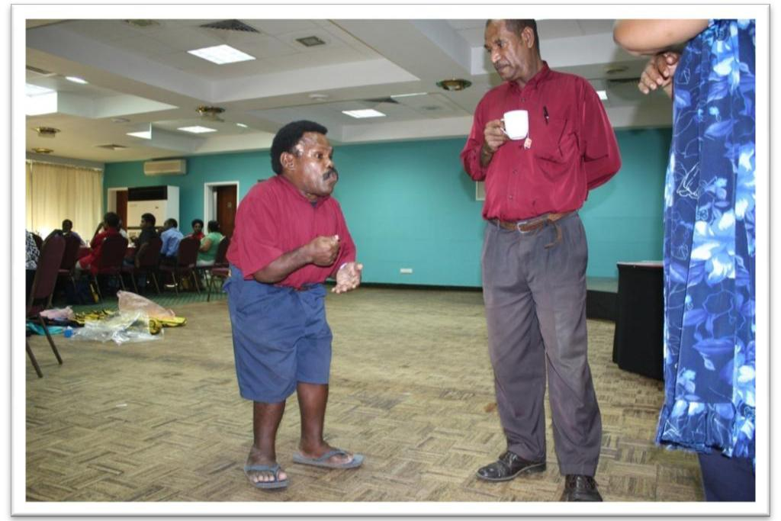

The Future | 57
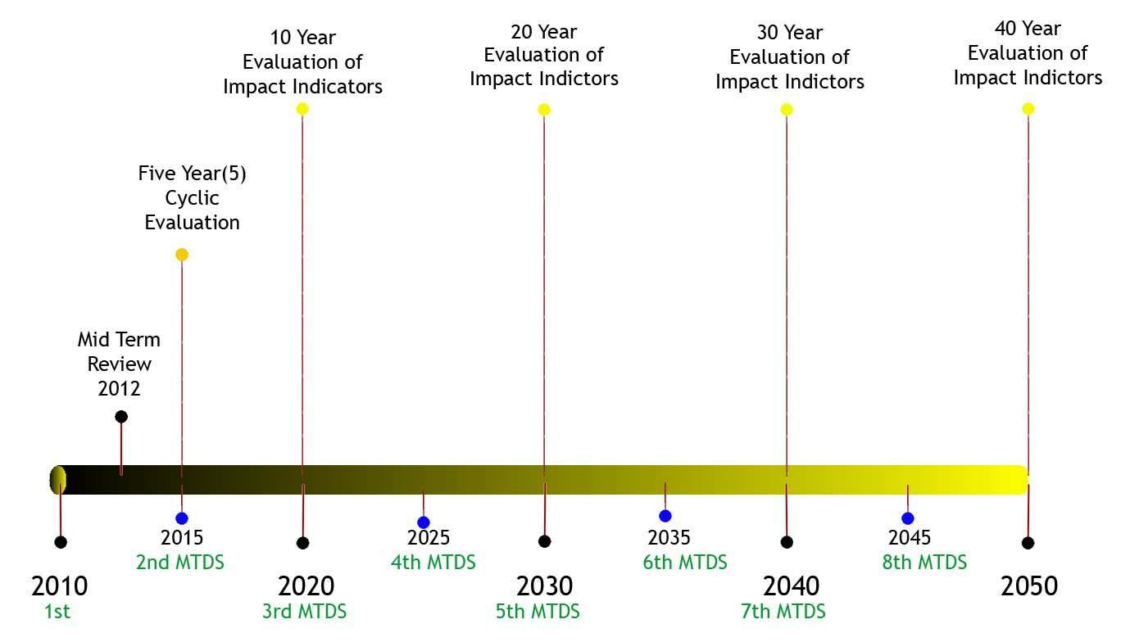

Figure 4.1: PNG Vision 2050 Review.

- Summary

Vision 2050 has a general timeframe of 40 years. It ensures flexibility so that the vision of our leaders and our people and the goals of Vision 2050 extend into the future. Our leaders and the people will regularly revisit their vision and evaluate Vision 2050. In the interim, the Department of Prime Minister and National Executive Council will oversee the management of, and provide recommendations to leaders on future directions with regard to strategy implementation. This will involve establishing processes to gather and utilise broad-based views and insights concerning the future of development in the country from all stakeholders.
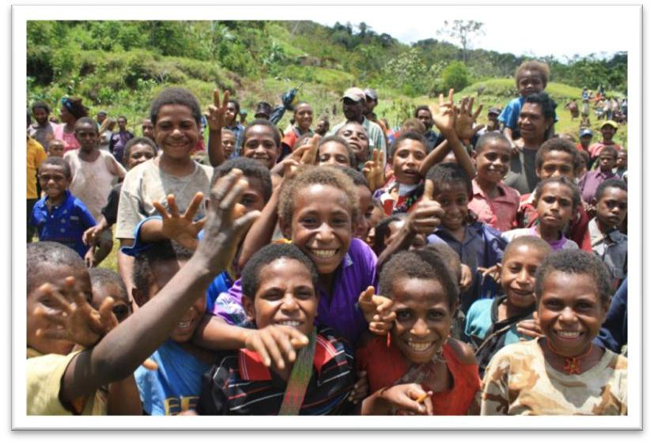
- Vision 2050

CHAPTER FIVE: THE FUTURE

Introduction

- The next 40 years: Based on the deterioration of the delivery of public goods and services and the lack of meaningful participation of the rural people in income-earning activities and their aspirations to do better, Vision 2050 is the National Government’s Strategic Directional Statements that will drive the development process over the next 40 years. The nation will strive to achieve the key outcomes through the seven Strategic Focus Areas in the 40 years, if there is:

  - a change in the mind-set of our people;

  - emergence of strong political leadership and will power;
  - improvement in governance;

  - improvement in the service delivery mechanism, underpinned by a committed and competent civil service work force;

  - an improved law and order situation, underpinned by fair and just law-enforcing agencies, and a population with strong morals, where the people respect one another; and

  - the realisation of acceptable growth potentials.

- Alignment and Operationalisation: Vision 2050 has an integrated perspective of development which encompasses institutional development and service delivery, human and social capital development, wealth creation, security and international relations, environmental sustainability and climate change and churches and development. When operationalised, there will be cross-cutting issues, such as institutional policies, budgets and human resources. Programs and policies at all levels will be aligned with the vision. It will have to be institutionalised through appropriate legislation to make it effective.

- Transformation: When the directional statements are implemented efficiently and effectively, Papua New Guinea can be transformed into an upper-middle income country by 2050. It would be better now, rather than later, as perceived by the National Executive Council, under the stewardship of Prime Minister, Grand Chief Sir Michael Somare, to have an overarching strategic plan. The current environment is blessed with political stability and the aspirations of the people for participation in economic development.

- Destiny: The Vision 2050 accepts the nation’s current development status and aspires for PNG to do better in the next 40 years so that it can become a ‘Smart, Wise, Fair and Healthy Happy Society by 2050’. Papua New Guinea will strive to improve its ranking in the United Nations HDI among the top 50 out of 182 countries, by 2050, from the current rank of 148, through the creation of opportunities for personal and national advancement, as a result of economic growth, smart innovative ideas, quality services and a fair and equitable distribution of benefits.

- Economy: In terms of robust economic growth, the modelling for Vision 2050 is quite conservative, even when taking into account the massive LNG projects that are anticipated to come on stream. This is consistent with accepted economic practice. The intention also is to ensure that structural changes in the economy are not dependent on the success of the LNG project, or other projects that are being planned. The most important strategy being mooted is that of a Sovereign Wealth Fund to quarantine the negative impact of large enclave developments on other parts of the economy. Also, if all petroleum and mining projects do come on line, this becomes a bonus for future governments and the use or quarantine of those funds will be determined during the reviews to be conducted as part of the Long Term Development Strategy process.

The Future | 59

- Assertiveness: Papua New Guinea can become a Smart, Fair, Wise, Healthy and Happy Society when all the directional statements under Vision 2050 are articulated, institutionalised, operationalised, and implemented, efficiently and effectively.

- Summary

Papua New Guinea Vision 2050 is the final product of the efforts of multitudes of Papua New Guineans from all walks of life, living in both rural and urban settings. We, as Papua New Guineans, have had the opportunity to develop a country of our own in the last 34 years, since we were afforded the opportunity by our forefathers including the Grand Chief Prime Minister Sir Michael Somare, through the attainment of political independence. We have in fact learned all the lessons and made all the mistakes that one could ever make and draw from to do better the next time around. The future of this country is now entirely in our own hands and therefore we cannot place the blame on others if we fail to learn from the past and chart out a new growth trajectory for the future. Indeed, Vision 2050 is a ‘people’s plan’ as well as a living document that should be reviewed in 2019 by the ensuing generation. What we have done here is to set key foundational targets that if implemented well will lay the foundation for the years to come after 2020. For optimal outcomes to be gained, implementation should be done in a cascading manner or hierarchy of strategic intent, whereby the Long Term Development Strategy should first take its cue from the mission statement of Vision 2050; sectoral strategies should in turn develop their visions from the LTDS mission statement; Provincial Development Strategies will likewise derive their visions from that of the LTDS; Districts, LLGs and Wards would then develop operating plans to implement the strategies of high order plans. Effective and timely programme evaluation through a robust monitoring protocol is critical in 2010 with religious application over the next forty year period in order to verify the country’s progress towards the vision and mission statement as well as to ensure that timely corrective actions are taken. Finally, any reorganisation of the Public Service ought to be aligned to the Vision 2050’s mission statement.
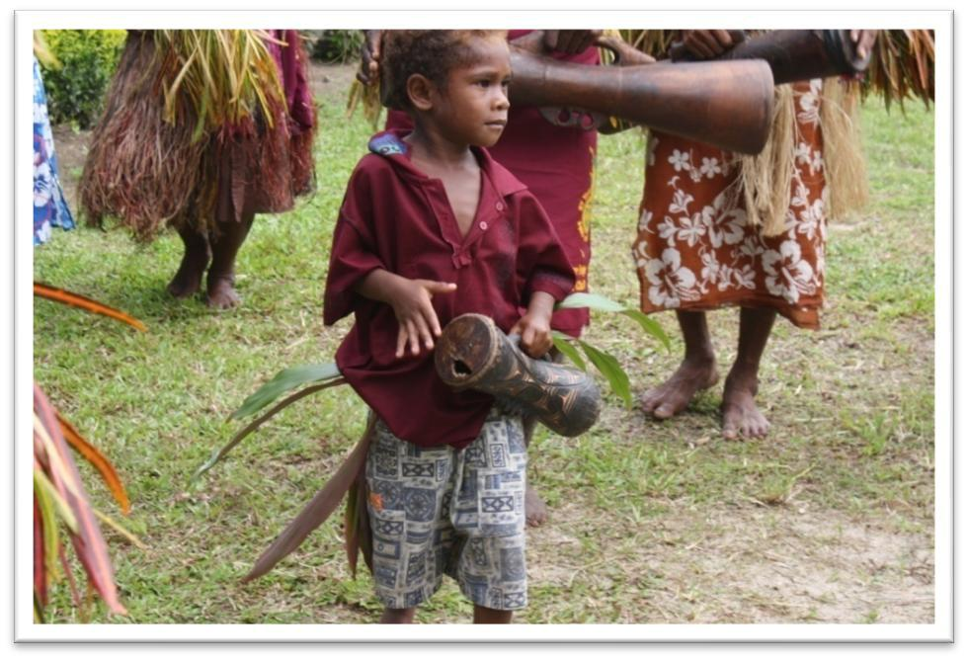
- Vision 2050

References

ACIL Tasman, 2008, PNG LNG Economic Impact Study (prepared for Exxon Mobil), Melbourne.

Allen, D., 1970, Report on New Guinea and Trust Territory of the Pacific Island 1959-1970, Government Printer Canberra.

Arndt, H., 1977, Shand, R. and Fisk, E.K., 1969. ‘An answer to Crocombe – I, II, III’, New Guinea, 4(2):54-71 (June/July).

Azeem et al., 1979, Development and Dependency: the political economy of Papua New Guinea, Oxford, Melbourne.

Bai, B.,2006, Improved Decentralisation: getting people involved in Democracy, Strong Civil Society, Public Sector Reform Advisory Group, Port Moresby

Bank of Papua New Guinea, 2007, Money and Banking in Papua New Guinea, Melbourne University Publishing, Melbourne.

Bank of Papua New Guinea, Bank of Papua New Guinea, 2007, Money and Banking in Papua New Guinea, Melbourne University Publishing, Melbourne.

Bank of Papua New Guinea, Quarterly Economic Bulletin, 2007 to 2009, various issues

Bank of Papua New Guinea, Monetary Policy Statements, 2008 to 2009, various issues

Bank of Papua New Guinea, 2007, Money and Banking in Papua New Guinea, Melbourne University Publishing, Melbourne.

Crocombe, R., 1968-69. ‘That five-year plan’, New Guinea, 3 (3):57-70 (December/January).

Curtin, T., 2000. ‘A new dawn for Papua New Guinea’s economy’, Pacific Economic Bulletin, 15(2): 1-35.

Curtin, P. W. E., 1965. ‘The World Bank Report: A review’, New Guinea, 1(1): 52-58.

Epstein, T. S., 1968. Capitalism, Primitive and Modern: Some Aspects of Tolai Economic Growth. Canberra:
The Australia National University Press.

Fairhead L, Kauzi G and Yala L, 2009 Draft, Land Reform in Papua New Guinea, Quantifying the Economic Impacts, National Research Institute, yet to be published Working Paper

Goodman, R.L., Lepani, C. and Morawetz, D., 1985. The economy of Papua New Guinea, an Independent Review. Pacific Policy Paper No.1, National Centre for Development Studies, Canberra: The Australia National University.

http://www.doingbusiness.org/features/statistics. Accessed 10 September 2009.

http://www.transparencypng.org.pg/news.html.

http://www.nationmaster.com/graph/cri_tot_cri_percap-crime-total-crimes-per-capita.

http://www.png.cpp.org.au/pngcpp/country_information.cfm. Accessed 9 October 2009.

References 61

John Lee Consultants, 2004. Papua New Guinea Transport Sector Review. Note with an emphasis on the Roads Sector.

Kaputin, J., 1969. ‘Australia’s carpetbaggers’, New Guinea, 4(1):35-42.

Kavanamur, D., 2007, The Development Story: bipo,nau na behain? In South Pacific Journal of Philosophy and Culture, Vol 9 2006-2007.

Kavanamur, D., 2002. ‘Papua New Guinea: 2001 political-economy review’, The Contemporary Pacific.
14(2): 456-461, Hawaii: University of Hawai’i at Manoa.

Kavanamur, D. and Okole, H., 2004, Understanding Reform in Papua New Guinea: an analytical evaluation in collaboration with Michael Manning and Theodore Levantis, Institute of National Affairs Port Moresby, Papua New Guinea.

http://muse.jhu.edu/journal/contemporary_pacific/v014/14.2kavanamur.html.

Momis, J., 1974 Constitutional Planning Committee Report.

Monetary Policy Statements, 2008 to 2009, various issues

National Statistical Office, National Accounts Statistics: 1994 to 2006, Port Moresby.

National Statistical Office, National Accounts Statistics: 1994 to 2006, Port Moresby.

National Strategic Plan Taskforce, 2008. The Papua New Guinea National Strategic Plan, 2010-2050. Final Report to National Development Summit, September 2008.

Organization for Economic Cooperation and Development, 2001. The Well-Being of Nations: The Role of Human and Social Capital. OECD.

Papua New Guinea Constitution, 1975, Port Moresby.

PNG Constabulary Policy Submission, 2009. File No.: 50-17-18.

PNG Power Ltd, 2006. National and Provincial Ten-Year Power Development Plan, 2007-2016. Port Moresby (December).

Reay, M., 1969. ‘But whose estate?’ New Guinea, 4(3):64-68 (September/October).

Samana, U., 1988. Papua New Guinea: Which Way? Essays on Identity and Development. Victoria: Arena Publications.

Somare, M., 1974, We Bilong yumi-et poin impruvmen plen/toktok bilong Namba Wan Minista Michael Somare, em bin givim lon Ekonomik Sosaiti bilong Papua NiuGini long Port Moresby

Schaffer, B., 1965. ‘Thoughts at Goroka: Sins of the World Bank Team’, New Guinea, 1(2): 72-79.

Telikom PNG, 2009. Corporate Plan.

UNDP, 2008. UNDP Human Development Report, 2007/2008. UNDP.

World Bank Report, 2007. http://hdr.undp.org/en/statistics/.

World Bank, 2008. (http://www.doingbusiness.org/features/Highlights2010.aspx Accessed 10/9/2009.
- Vision 2050

World Health Organization, 200. Western Pacific Country Health Information Profiles, WHO.

World Vision, 2009, http://www.worldvision.org/content.nsf/learn/world-vision-papua-new-guinea.

World Bank, 2008, (http://www.doingbusiness.org/features/Highlights2010.aspx Accessed 10/9/2009

World Bank, 2007, Country Assistance Strategy for Papua New Guinea: In International Bank for Reconstruction and Development, International Development Association and International Finance Corporation, Report No. 41571-PG


References 63

ACKNOWLEDGEMENTS

The National Strategic Plan Taskforce (NSPT) acknowledges the tireless efforts and contributions of many prominent Papua New Guineans in mapping out a 40-year vision for the nation. The NSPT members are; Professor David Kavanamur, Daniel Kapi, Avia Koisen, Lady Aivu Tauvasa, Ambassador Peter Peipul, Allan Bird, Michael Malabag, Paul Bengo, Robert Agorobe, Simon Kenehe, Rev. Samson Lowa, and David Sode.

The NSPT engaged the services of many individuals in the development of The Papua New Guinea Vision 2050. The technical advisers were engaged on the basis of their skills and expertise in the various core pillars, and we acknowledge their valuable contributions.

- Pillar No. 1: Human and Social Capital Development — Dr. John Kola, Dr. William Tagis, Dr. Paul Ngabung, Dr. Michael Unage, and George Bopi.

- Pillar No. 2: Wealth Creation, Natural Resources and Growth Nodes — Dr. Sebastian Bagrie, Associate Professor Billy Manoka and Professor Subba Rao.

- Pillar No. 3: Institutional Development and Service Delivery — Kilyali Kelly Kalit, Peter Yaki Mision, Dr. Musawe Sinebare, Dr. Joseph Ketan, Daniel Aloi, Associate Professor Eric Kwa and the Service Delivery Mechanism Model led by Mr Paul Songo.

- Pillar No. 4: Security and International Relations — Gabriel Dusava, Ambassador Max Rai, Samuel Era and Peter Aigilo.

- Pillar No. 5: Environmental Sustainability and Climate Change — Professor Chalapan Kaluwin, Goodwill Amos, Willie Asigau, Nalau Bingeding, John Genolagani and Rufus Mahuru.

- Pillar No. 6: Spiritual, Cultural and Community Development — Dr. Misty Baloiloi and church leaders.

- Pillar No. 7: Strategic Planning, Integration and Control — Jerry Wemin, Professor Albert Mellam, Dr. Gae Kauzi, Dr. CLN Pillai, Rosie Johnson and Yasap Popoitai.

- National Strategic Plan Secretariat: Dr. Vele Pat Ila’ava, Andrew Kavana, Peter Farapo, Angela Taukei, Kevin

Kautu Hwasihao, Jon Kombeng, Clement Teteret, Steven Mombi, Ralph Yamb, Westly Nukundj and Vui Verave; Extraordinary editorial and typesetting assistance were rendered by Jim Robins, Georgia Kaipu, Mary Unido and Benjamin Cheong.

The members of the Taskforce for Government and Administrative Reforms are also acknowledged — Sir Barry Holloway, Graham Tuck, Camilla Angoro, Priscilla Peter, Getrude Miria and Casper Yoanes.

The support of the senior officers in the Department of Prime Minister and NEC are acknowledged — Ms. Margaret Elias, Acting Secretary, Department of Prime Minister and NEC and Acting Chief Secretary to Government Mr. Manasupe Zurenuoc, Dr. Angelica Braun, Noel Mobiha and support staff from the Department; and special thanks to the PSRMU Director, Bill Kua, Deputy Director Joseph Sukwianomb, Phillip Leo, Monica Spaminiah, Linda Sataro, Max Yallon, Esther Moses and the SDMM Team together with other support staff for their undivided support throughout the development of Vision 2050.

The contribution of the following peer reviewers is also acknowledged. Dr Henry Okole, Dr Bill Standish, John Silikara and Emmanuel Gorea. The support of the following institutions is also appreciated, National Research Institute, PNG Institute of Public Administration, Bank of Papua New Guinea, Department of Provincial Affairs and Local Level Government and Department of National Planning and Monitoring.

The NSPTF also acknowledges the participation of all government departments, provincial administrations, district administrations, local-level governments, the private sector, NGOs, churches, and the people of Papua New Guinea for contributing to The Papua New Guinea Vision 2050 through the stakeholder and district consultations that took place between June and September 2009. Special thank you goes towards the United Nations (PNG), Australian Government, United States Government, European Union and other international development partners, who made critical inputs during the consultation stages.

Finally, the task of completing the Papua New Guinea Vision 2050 would not have been possible without the endorsement and guidance of the National Planning Committee chaired by the Deputy Prime Minister Sir Dr Puka Temu.

PROFESSOR DAVID KAVANAMUR

Chairperson, National Strategic Plan Taskforce

